Physical Diagnosis 2 · Exam 1 — Study Guide
Editable Word copy of the PA_Quizzes study aid. Headings use real Word styles, so the navigation pane and the contents field below both work, and restyling one heading restyles them all.
[In Word: right-click here and choose Update Field to build the contents.]

1 · Clinical Reasoning, Documentation & the Encounter
INSTRUCTIONAL OBJECTIVES
Topic Outline: Application of Clinical Reasoning and Problem-Solving Abilities and Effective Exchange of Information
- Describe the format and components of a comprehensive patient history and physical examination to enhance clinical reasoning.
- Describe the role of small groups and simulations in fostering clinical reasoning and problem-solving skills.
- Discuss the application of clinical reasoning in crafting oral presentations that accurately reflect patient care scenarios.
- Discuss the importance of clinical reasoning during an Objective Structured Clinical Examination (OSCE).
- Differentiate between a comprehensive and focused patient history and physical examination.
- Differentiate between the documentation of a complete history and physical examination and a problem-focused subjective-objective assessment and plan (SOAP).
- Demonstrate documentation of a complete history and physical examination.
- Explain the importance in involving the patient in healthcare communication.

NOTE
Where this material actually lives. Objectives (a), (e), (f) and (g) are documentation objectives, and the Lecture 1 deck does not teach them — it assumes you carry them forward from Physical Diagnosis I, and says so directly: review the documentation content from PD I. They are answered below, and the PD I Exam 3 guide covers the same ground section by section if you want the long version.

1.1 · Objective a — Format and components of the comprehensive history and physical
A comprehensive history and physical is the full record of an encounter, taken in a fixed order so that nothing is lost and so that anyone reading it later finds each piece where they expect it. The components, in the order they are gathered and written:
Component | What it holds
Chief complaint | Why the patient came, in their own words where possible
History of present illness | The narrative of the current problem, built from the seven attributes of a symptom
Past medical history | Previous illnesses, hospitalizations, surgery
Medications and allergies | Prescription and over-the-counter, with the reaction for each allergy
Family history | Heritable disease in first-degree relatives
Social history | Habits, occupation, exposures, living situation
Review of systems | System-by-system screening for symptoms not yet volunteered
Physical examination | What you found, described rather than labeled
Assessment and plan | Differential, working diagnosis, testing, treatment, education, follow-up

The reason the order is fixed is the reason it enhances clinical reasoning: the history narrows the differential before you touch the patient, and the examination is then aimed at what the history raised. A history taken out of order tends to produce an examination that wanders.

1.2 · Objectives b & d — Small groups, simulation and the Objective Structured Clinical Examination
These three formats all exist to make you reason out loud, which is the one thing reading cannot teach.
Format | What it trains
Small groups | Justifying every information request. You must explain why a piece of information is needed and what it would tell you about the patient — the facilitator withholds it until you do. That constraint is deliberate, and it is the whole exercise: it converts “order a complete blood count” into a hypothesis with a reason attached.
Simulation | Reasoning against a moving target. Vitals are monitored live, laboratory and imaging results arrive during the scenario, and the plan has to change as the mannequin changes. A debriefing with reflection and feedback closes each session.
Objective Structured Clinical Examination | The whole chain end to end and under time: focused history, focused examination, differentials, studies, diagnosis, treatment plan with patient education, and a one-minute case presentation.

The common thread is that none of them rewards recall alone. The small group will not hand you data without a justification, the simulation changes underneath you, and the Objective Structured Clinical Examination asks for a plan rather than a list of findings.

1.3 · Objective c — The oral case presentation
A presentation is a well-organized vignette that describes the patient and the clinical problem — not the written note read aloud. The provider's goal is to help the listeners visualize the patient and understand the problem.
Element | Rule
Opening statement | Include the past medical history and the chief complaint
Content | Pertinent positives and negatives, from both the history and the physical examination
Order | Mostly the order in which you obtained the history and performed the examination
Delivery | Try not to read your notes

The test of a good presentation: it leads your facilitator to the same differential you formulated. That is a functional test, not a stylistic one — and it is where the clinical reasoning shows. Selecting what counts as pertinent is the reasoning being assessed. A presentation that includes everything has made no decisions.

1.4 · Objective e — Comprehensive versus focused
The distinction that matters, and the one most often got wrong: a focused encounter narrows both the history and the examination. It is not a comprehensive encounter written up more briefly, and it is not a full history with a short examination.
 | Comprehensive | Focused
History of present illness | Full | Focused
Review of systems | Complete, system by system | Focused
Past medical history | Full | Focused
Social history | Full | Focused
Family history, medications, allergies | Full | Focused
Physical examination | Head to toe | Systems pertinent to the complaint

A focused encounter still has to produce the whole reasoning chain: differentials, laboratory and imaging studies, a diagnosis, and a treatment plan including patient education. Narrowing the data gathered does not narrow what you are expected to conclude from it.
How far does a focused examination reach? Examine the systems pertinent to the chief complaint and the positive history, and when in doubt go one system up and one system down. Two questions settle the rest: what must be examined to rule out the worst-case scenario, and what are your differentials and how do you rule each in or out?
Also tested
- Focused versus comprehensive encounter. In a focused encounter the history and examination are both narrowed to what the presenting problem requires; it is not a shorter version of everything, but a targeted selection.

1.5 · Objective f — The complete history and physical versus the SOAP note
Both document an encounter. They differ in scope and in purpose.
 | Complete history and physical | SOAP note
Scope | Comprehensive — the entire history and a head-to-toe examination | Problem-focused
When used | New patient, admission, annual comprehensive visit | A visit addressing a defined problem, and follow-up
Structure | Chief complaint, history of present illness, past medical history, medications, allergies, family history, social history, review of systems, examination, assessment, plan | Subjective, Objective, Assessment, Plan
Examination | All systems | Focused, but always with a general assessment or impression

SOAP section | Shorthand | What goes in it
Subjective | What the patient said | Narrative history, pertinent positives and negatives, medical and surgical history, family and social history, review of systems, medications, allergies
Objective | What you found | Observations, measurements and tests performed during the encounter; the focused examination; always a general assessment or impression
Assessment | What you concluded | The diagnosis drawn from history, examination and testing, plus chronic and concurrent conditions
Plan | What you will do | Disposition, testing, treatment, referrals, patient education, follow-up

1.6 · Objective g — Documenting the complete history and physical
The rules that get marked against you, taken from the clinical assignment guidance:
Rule | Why it exists
Describe findings rather than writing normal, abnormal or unremarkable | A description communicates what you actually observed; a label communicates only that you formed an opinion
No abbreviations | Stated without qualification — there is no “once defined on first use” allowance
Keep subjective and objective information in their own sections | Blending them is one of the commonest documentation errors, and it hides which claims are the patient's and which are yours
If you did not do something, document why | You may not invent a finding. This is the one rule treated as absolute
You may not write your note with another student | Even when you saw the same patient, the note is your own work
Review the grading rubric and the comments on prior assignments before submitting | Prior feedback is the most direct guide to what still needs fixing

NOTE
You can plagiarise yourself. Per the Student Handbook, work submitted for academic credit must be the original work of the student, and work is not original when it has been submitted previously by the author or by anyone else. Reusing your own template from an earlier assignment is the trap being flagged.

Also tested
- Subjective and objective information. Each is kept in its own appropriate section of the note rather than mixed together.

1.7 · Objective h — Involving the patient in healthcare communication
Communication is a skill that is graded, and it is expected to adapt in style and content for each patient rather than follow one fixed script.
The rule stated most emphatically: when someone other than the patient is supplying the answers, you should always be looking at and interacting with the patient, not with whoever is speaking. The encounter is with the patient even when the words come from elsewhere. In the Objective Structured Clinical Examination the “patient” gives no verbal responses beyond identifying data and the facilitator answers for them — which is precisely the situation this rule is built for.
A related expectation: accept constructive feedback and modify behavior, and expect different facilitators to give different feedback. The variation is anticipated rather than a contradiction to be resolved.
Source: Intro to PD II - Elwaya .pdf (Professor Ayelet Elwaya), Pages 1–23, and the PAJ 5310 syllabus instructional objectives. Documentation content carried forward from Physical Diagnosis I.

2 · Dermatological History & Examination
INSTRUCTIONAL OBJECTIVES
Topic Outline: Advanced Dermatological System Medical History and Examination
- Review the anatomical structure and function of the skin.
- Review the terms used to describe lesion type (primary morphology), lesion configuration (secondary morphology), texture, distribution, and color of skin lesions.
- Describe the elements related to interviewing and eliciting a medical history that aid in identifying skin, hair, and nail disorders.
- Describe physical examination findings of abnormal conditions related to skin, hair, and nails.
- Demonstrate the proper clinical skills for a complete and focused physical examination of the skin.

NOTE
Scope note. This is the examination lecture: how to take the history, how to perform the examination, and what to call what you see. Dermatology also appears in Clinical Pathophysiology I this term (mechanism) and in Clinical Medicine and Surgery I (diagnosis and management). The three do not conflict — they are three different questions about the same diseases.

2.1 · Objective a — Structure and function of the skin
Five functions: protection of internal structures · prevention of entry of microorganisms · temperature regulation · excretion · production of vitamin D.
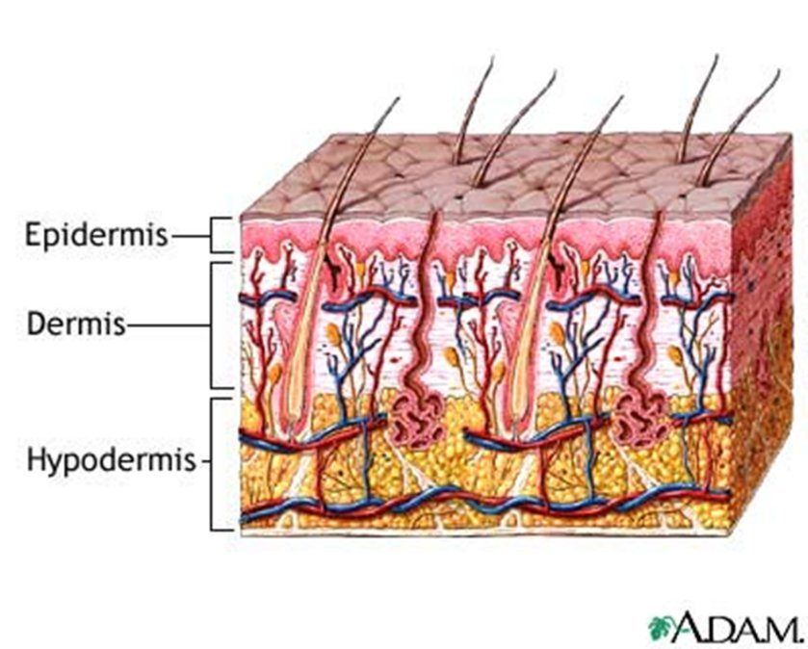
The three layers, and why the morphology definitions care about them. A lesion confined to the epidermis is superficial — that is an erosion, which stays moist and does not bleed. Reach the dermis , where the vessels run, and it can bleed and scar — that is an ulcer. A nodule sits deeper in the dermis than a papule, and a cyst may sit deeper still, in the subcutaneous layer. Source: PD II Derm - Beck.pptx, Slide 3.
Gland | Secretes | Notes
Sudoriferous (eccrine) | Sweat | Maintains body temperature
Apocrine | Pheromones | Becomes active during puberty
Sebaceous | Sebum | Surrounds the hair follicle; keeps hair and skin moist

Hair type | Character | Where
Vellus | Short, fine | Covers the body
Terminal | Coarse | Scalp, pubic, axillary, beard

2.2 · Objective b — The descriptive vocabulary
★ PROFESSOR EMPHASIS
★ Professor emphasized
This vocabulary is the backbone, not a glossary to skim. “This is what’s very important … this is going to be really important for every system that you learn within physical exam lab and physical exam lectures. These are going to be the backbone of how you write your notes and how you communicate to other providers.”
She is saying this section outlives dermatology — it is how you will describe findings in every organ system for the rest of the course.

Five features describe any lesion: distribution (location) · configuration (shape) · morphology (form and structure) · color · texture.
Distribution — unilateral, bilateral, symmetric, asymmetric, photodistribution, intertriginous, flexural, extensor, palmar-plantar, hair-bearing areas. Distribution is often the fastest route to a diagnosis:
Distribution | Suggests
Generalized or diffuse | Allergic reactions
Regional (confined to one body area) | Tinea capitis
Sun-exposed (photodistribution) | Skin cancers
Dermatome | Herpes zoster
Extensor | Psoriasis
Flexor | Atopic dermatitis is the classic example (the inner elbows and the backs of the knees); intertrigo, inflammation in skin folds, is also paired with this pattern
Intertriginous (creases and folds) | Involvement of skin folds

Configuration — the shape the lesions make together:
Term | Meaning
Annular | Shaped like a ring; round
Arciform | Forms arcs or curves
Confluent | Lesions run together
Discrete | Lesions remain separate
Grouped | A cluster of lesions
Gyrate | Twisted, coiled, spiral, snakelike
Herpetiform | Grouped papules or vesicles arranged as in herpes simplex
Iris (target) | Shaped like a bull's eye
Linear | Forms a line or stripe
Reticular | Lacy or networked pattern
Serpiginous | Snake-like
Zosteriform | Clustered in a dermatomal distribution, as in herpes zoster

The pair most often confused: herpetiform is grouping like herpes simplex; zosteriform is a dermatomal band like herpes zoster. Both are named for an infection, which is what makes them easy to swap.
Also tested
- Psoriasis distribution. Psoriasis characteristically appears in an extensor distribution; the elbows and knees are the classic extensor sites.

2.3 · Objective b — Primary morphology
★ PROFESSOR EMPHASIS
★ Professor emphasized — and a cross-course warning
Beck uses ONE CENTIMETER as the macule/patch boundary. “A macule is less than one centimeter, it is a flat discoloration — that’s important. A patch is going to be a flat discoloration that’s more than one centimeter. Okay? That’s important.”
Clinical Pathophysiology teaches five millimeters for the same lesions, and Professor Gopal said her numbers are the ones her exam uses. Both lectures ran on 2026-08-18, three hours apart. Neither is wrong — they are different conventions, and each course examines its own. Use one centimeter here and five millimeters there.
Neither of them will ask a borderline case. Beck: “My exam question is not going to involve this … I’m not going to ask you ‘it’s point seven five centimeters’ … so it’s going to be very clear.” Gopal, the same day: “it’s not gonna be a gotcha thing on the exam.” Know the numbers — they are fair game. What neither of them will do is make a borderline value the crux of the question, so you will not be asked to call a 0.75 cm lesion. Learn the boundaries; do not agonize over the edge cases.

A primary lesion forms first and results directly from the disease. Identifying it is the key to interpretation and description — every later description depends on getting this right.
One centimeter is the hinge. Four of the definitions below turn on it, in matched pairs: flat under and over (macule / patch), solid elevated under and over (papule / plaque), fluid-filled under and over (vesicle / bulla). Learn the three pairs and you have six of the terms. Bring a ruler — that is why one is on the equipment list.
Lesion | Definition | Size | Example
Macule | Circumscribed, flat discoloration — brown, blue, red or hypopigmented | < 1 cm | Freckles
Patch | Circumscribed, flat discoloration; a large macule, or macules that coalesce | > 1 cm | Vitiligo, café au lait spots
Papule | Palpable, elevated solid mass | < 1 cm | Nevi, warts, lichen planus
Plaque | Palpable, elevated solid mass, plateau-like; elevated, flat-topped, firm, rough; occupies a large area compared with its elevation; may be coalesced papules | > 1 cm | Psoriasis
Nodule | Elevated, firm, circumscribed; round or ellipsoid; deeper in the dermis than a papule | 1–2 cm  (Bates says larger than 0.5 cm) | Basal cell carcinoma, neurofibromatosis
Tumor | Palpable, elevated solid mass | > 2 cm | Neoplasms
Wheal | Elevated irregular-shaped area of cutaneous edema; solid, transient | Variable | Allergic reaction
Vesicle | Superficial elevation filled with fluid | < 1 cm | Blister, herpes simplex
Bulla | Superficial elevation filled with fluid | > 1 cm | Large blister
Pustule | Superficial elevation filled with purulent material | Usually < 1 cm | Acne, impetigo
Cyst | Elevated, circumscribed, encapsulated; in the dermis or subcutaneous layer; liquid or semisolid contents | — | Sebaceous cyst

Two lesions are defined by something other than size. A wheal is the only transient one — if it is gone by the next visit, that is the finding, not a missed examination. A cyst is the only encapsulated one, which is what separates it from a nodule you can feel at the same depth.
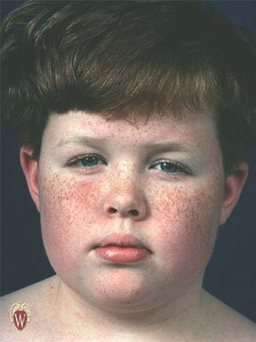  Macules — freckles. Circumscribed, flat discoloration under one centimeter. Run a finger across them and you feel nothing; that is what makes them macules rather than papules. Source: PD II Derm - Beck.pptx, Slide 32. | 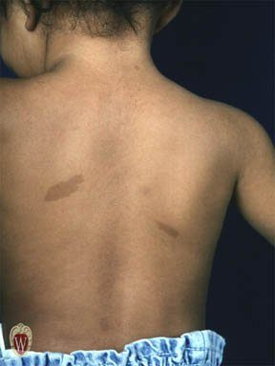  Patches — café au lait spots. The same flat discoloration as a macule, but larger than one centimeter. A patch may also be several macules that have coalesced. Source: PD II Derm - Beck.pptx, Slide 33. | 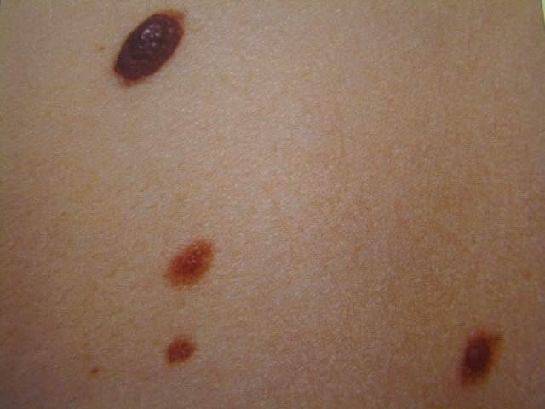  Papules — nevi. Palpable, elevated, solid, under one centimeter. Elevation is the whole distinction from a macule, and it is found by touch rather than by looking. Source: PD II Derm - Beck.pptx, Slide 34.
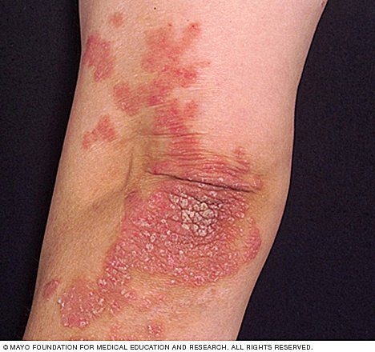
Plaques — psoriasis. Elevated, flat-topped, firm and rough, larger than one centimeter, and occupying a large area compared with how far they rise. Note the extensor location: distribution and morphology are pointing at the same diagnosis. Source: PD II Derm - Beck.pptx, Slide 35.

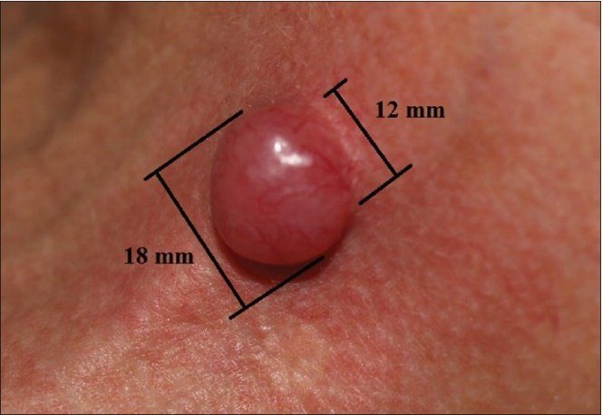  A nodule , measured. Elevated, firm, circumscribed, round or ellipsoid, and sitting deeper in the dermis than a papule. This is why a ruler is on the equipment list — at eighteen millimeters this is a nodule, and at over twenty it would be a tumor. Source: PD II Derm - Beck.pptx, Slide 36. | 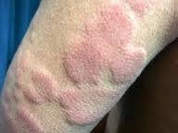  Wheals — an allergic reaction. Elevated, irregular areas of cutaneous edema: solid, of variable diameter, and the only primary lesion that is transient . If it has gone by the next visit, that is the finding rather than a missed examination. Source: PD II Derm - Beck.pptx, Slide 37. | 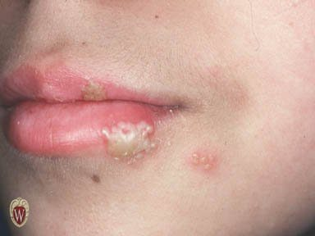  Vesicles — herpes simplex. Superficial elevations filled with fluid, under one centimeter. The grouping is worth naming too: papules or vesicles clustered like this are described as herpetiform . Source: PD II Derm - Beck.pptx, Slide 39.
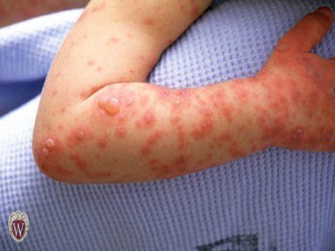
Bullae . The same superficial fluid-filled elevation as a vesicle, over one centimeter. Size is the only thing separating the two terms. Source: PD II Derm - Beck.pptx, Slide 40.

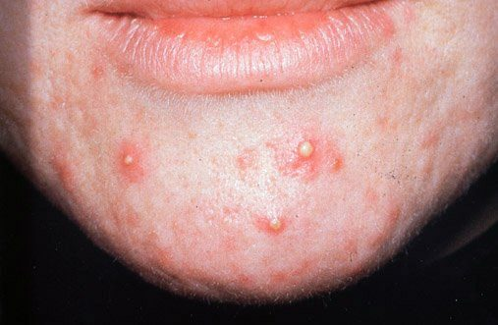  Pustules — acne. Superficial elevations filled with purulent material, usually under one centimeter. Contents are what separate a pustule from a vesicle, not size. Source: PD II Derm - Beck.pptx, Slide 41. | 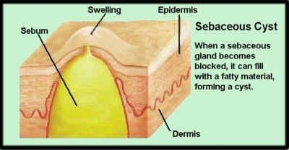  A cyst — elevated, circumscribed and encapsulated , sitting in the dermis or subcutaneous layer and filled with liquid or semisolid material. The capsule is the distinguishing feature; a nodule at the same depth has none. Source: PD II Derm - Beck.pptx, Slide 42.

2.4 · Objective b — Secondary morphology
A secondary lesion is a change in a primary lesion over time — from disease progression, from treatment, or from manipulation such as picking or scratching. That third cause is worth holding on to: the patient's own hands change the examination.
Lesion | Definition | Example
Crust | Collection of cellular debris, dried serum and blood — a scab. The antecedent primary lesion is usually a vesicle, bulla or pustule | —
Erosion | Loss of superficial epidermis, does not involve dermis; surface is moist but does not bleed | The moist area after a bulla or vesicle ruptures
Ulcer | Deeper loss of epidermis and/or dermis; may bleed and scar | Stasis ulcer of venous insufficiency
Fissure | Linear crack in skin | Athlete's foot
Scale | Thin flake of exfoliated epidermis | Dandruff, cradle cap
Excoriation | An abrasion or scratch mark; may be linear or rounded | Scratched insect bite
Scar (cicatrix) | Replacement of destroyed tissue by fibrous tissue. Thick and pink (hypertrophic) or thin and white (atrophic); does not extend beyond the injured area | —
Keloid | Scar that grows beyond the wound | —
Lichenification | Thickening with skin line accentuation; roughening and thickening of epidermis; caused by chronic irritation | Atopic dermatitis
Collarette scale | Fine scale, peripherally attached and centrally detached, on the edge of an inflammatory lesion | Pityriasis rosea

Erosion versus ulcer is the discrimination worth being certain about: an erosion stops at the epidermis, is moist, and does not bleed or scar; an ulcer reaches the dermis, may bleed, and may scar. Depth determines all three consequences at once.
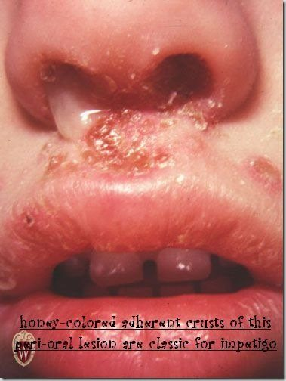  Crust — the honey-colored adherent crusting of impetigo. Cellular debris, dried serum and blood: a scab. Work backwards from it, because the antecedent primary lesion is usually a vesicle, bulla or pustule. Source: PD II Derm - Beck.pptx, Slide 43. | 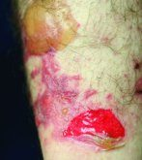  Erosion — the moist area left after a bulla or vesicle ruptures. Loss of superficial epidermis only: the surface is moist but does not bleed , because the dermis has not been breached. Source: PD II Derm - Beck.pptx, Slide 44. | 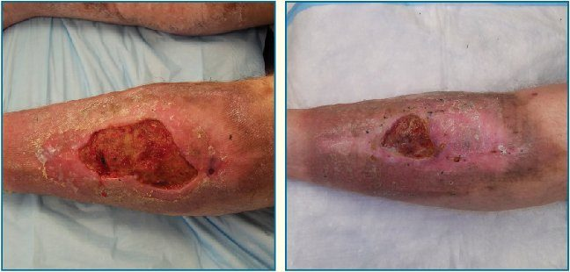  Ulcer — a stasis ulcer of venous insufficiency, shown before and after healing. Deeper loss of epidermis and dermis, so it may bleed and it may scar. Depth decides all three consequences at once. Source: PD II Derm - Beck.pptx, Slide 45.
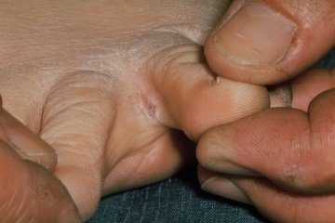
Fissure — a linear crack in the skin, here between the toes in athlete's foot. Same site as tinea pedis on the infection slide, which is not a coincidence. Source: PD II Derm - Beck.pptx, Slide 46.

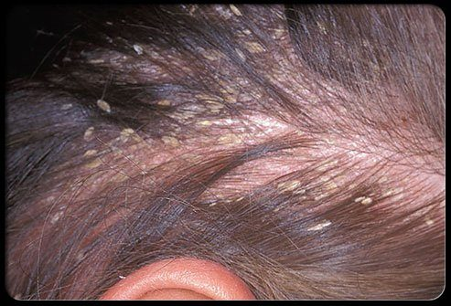  Scale — thin flakes of exfoliated epidermis. Distinguish it from crust by what it is made of: scale is shed epidermis, crust is dried serum, blood and debris. Source: PD II Derm - Beck.pptx, Slide 47. | 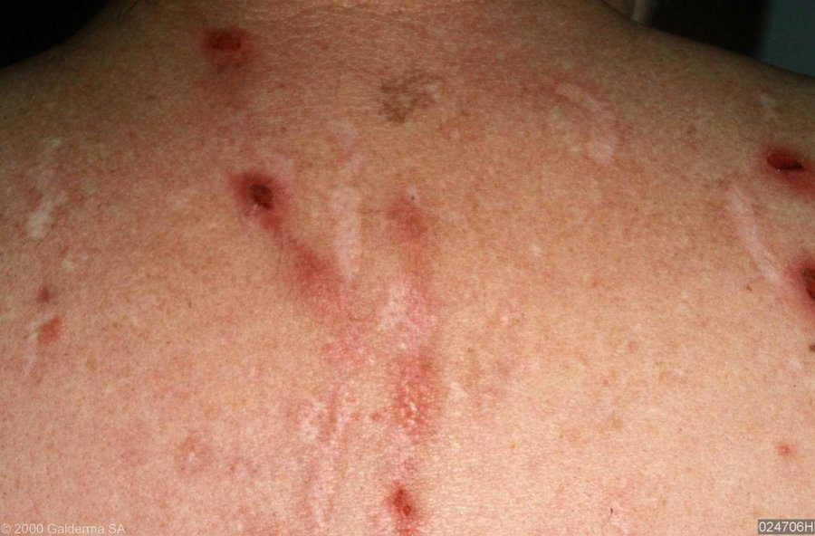  Excoriations — abrasions or scratch marks, which may be linear or rounded. This is the secondary lesion caused by manipulation rather than by the disease, and it tells you the eruption itches. Source: PD II Derm - Beck.pptx, Slide 48. | 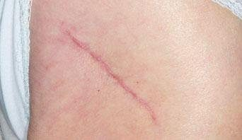  A scar — fibrous tissue replacing destroyed tissue. Thin and pale is atrophic, thick and pink is hypertrophic, and either way a scar does not extend beyond the injured area . That last clause is what separates it from a keloid. Source: PD II Derm - Beck.pptx, Slide 49.
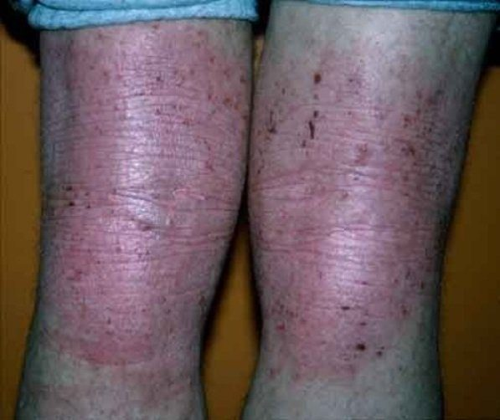
Lichenification — thickening with skin line accentuation , from chronic irritation in atopic dermatitis. The exaggerated creases are the finding. Note the flexural distribution, and the excoriations that explain the mechanism. Source: PD II Derm - Beck.pptx, Slide 52.

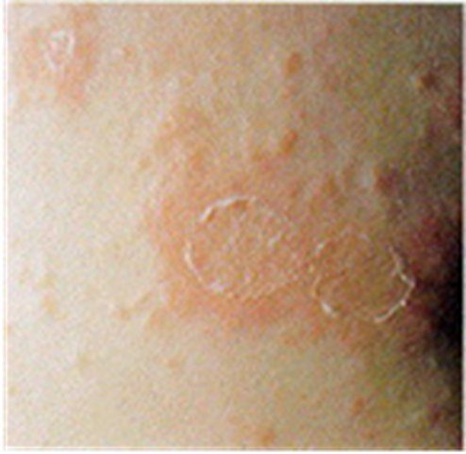
Collarette scale — pityriasis rosea. Fine scale attached at the periphery and detached at the center , sitting on the edge of an inflammatory lesion. Which end is attached is the entire definition. Source: PD II Derm - Beck.pptx, Slide 53.

Also worth knowing | Detail
Verrucae (warts) | Caused by human papillomavirus. Small harmless tumors of the skin; gray to flesh colored nodules raised from the surface, sometimes with rough hornlike projections
Corn | Smaller than a callus; usually over a non-weight-bearing area of the foot; conical structure of keratin pointing toward the dermis
Callus | Thickening of epidermal keratin; usually on the sole of the foot, at the ball or heel

Also tested
- Keloid. A keloid is a firm raised scar-tissue lesion, more common in darker-skinned individuals. It is commonest on the shoulders and upper chest but also arises at piercing sites, including the ear.

2.5 · Objective c — The dermatological history
The five core questions: where did the problem first appear · what did it look like · how has it progressed or changed · any associated symptoms · what treatment has been tried.
Think bugs, drugs, contact. Three exposure categories, and the fastest way to remember what else to ask: bugs — family members or contacts with the same, travel; drugs — systemic medications, both over-the-counter and prescription; contact — allergens and irritants from hobbies, occupation and environment.
Area | What to ask
Existing skin abnormalities | Changes in color · changes in shape (border, elevation, diameter) · changes in size · pain · bleeds easily · non-healing areas
Onset | Duration; acute versus chronic
Relationships | Season, travel history, heat or cold, previous reactions, drugs, menses
Skin symptoms | Pruritus, pain, paresthesia
Past medical history | Previous problems; systemic disease; personal dermatology history including disease and surgery
Family history | Skin cancer, psoriasis, allergies, infestations, infections
Psychosocial | Personal habits, exposures. Psychological stress is seldom the sole cause but can exacerbate many dermatoses

NOTE
Pruritus is not a diagnosis. It is the sensation that causes the desire to scratch. Generalized itching with no obvious reason has a wide differential — dry skin, aging, pregnancy, uremia, jaundice, lymphomas, leukemias, drug reaction and lice. Other sensations to ask about: burning, pain or tenderness, tingling, a creeping or crawling feeling, and whether it is intermittent or continuous.

Patients with cognitive problems may not attend to hygiene. If the hygiene of the skin, hair or nails appears inadequate, that is a finding — assess the social history, cognition, and ability to perform activities of daily living.
Also tested
- Pruritus. It is a sensation that causes the desire to scratch and is not itself a diagnosis; treating it as a diagnosis is an error.

2.6 · Objective d — Abnormal findings: the skin
★ PROFESSOR EMPHASIS
★ Professor emphasized
The pressure ulcer stages. “These are very important. You’re gonna come across it.” She then walked stage one in full — intact skin, erythema that fails to blanch, and the four changes: temperature (warmth or coolness), consistency (firm or boggy), sensation (pain or itching), and color.
The melanoma letters. “Things to look out for and to remember … you wanna remember the A, B, C, Ds … that’s really important.” She stopped and taught them from scratch when the class had not met them before.

Vascular lesions. The maneuver that separates blanching from non-blanching lesions is diascopy: press a piece of clear glass or plastic against the skin and look at the lesion under pressure. If the color fades, there is vascular engorgement; if it does not fade, it is hemorrhage in the skin.
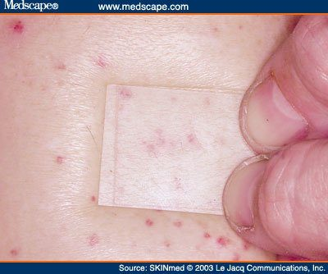
Diascopy. Press clear glass or plastic against the lesion and look at it under pressure. Here the spots persist under the glass — no blanching, so this is hemorrhage in the skin . Had the color faded, it would be vascular engorgement instead. One maneuver separates blanching lesions (engorged vessels) from non-blanching ones (blood leaked out of the vessels). Source: PD II Derm - Beck.pptx, Slide 55.
Lesion | Appearance | Size | Blanches?
Petechiae | Reddish-purple macules | < 3 mm | No
Purpura | Reddish-purple macules | 3 mm – 1 cm | No
Ecchymosis | Purple or purplish-blue macules, fade over time | > 1 cm | No
Cherry angioma (Campbell De Morgan spots) | Dome shaped, bright red to violet or black | — | Sometimes
Telangiectasia | Fine, irregular blood vessels | — | Yes
Spider angioma | Central red macule with radiating spider-like arms | — | Yes

Petechiae, purpura and ecchymosis are the same finding at three sizes, and none of them blanches — because the blood is outside the vessels. Under 3 mm, 3 mm to 1 cm, over 1 cm.
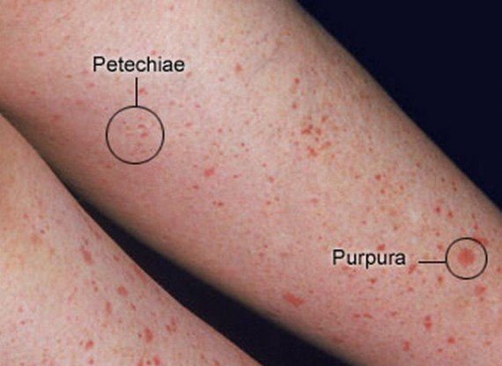  Petechiae and purpura on one leg, labeled. Same finding at two sizes: petechiae under three millimeters, purpura from three millimeters to one centimeter. Neither blanches. Over a centimeter and it becomes an ecchymosis. Source: PD II Derm - Beck.pptx, Slide 56. | 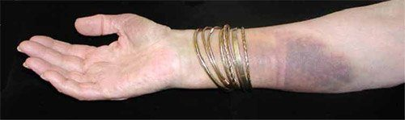  Ecchymosis — over one centimeter, purple to purplish-blue, non-blanching, and it fades over time as the extravasated blood breaks down. Petechiae and purpura fade the same way as the leaked blood is reabsorbed. Source: PD II Derm - Beck.pptx, Slide 57. | 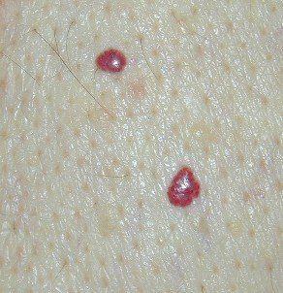  Cherry angiomas , also called Campbell De Morgan spots. Dome shaped, bright red to violet or black, and they may or may not blanch — which is why they sit awkwardly between the blanching and non-blanching groups and are best learned by their shape. Source: PD II Derm - Beck.pptx, Slide 58.

Dermatographism — “writing on skin”, a hive-type (urticarial) reaction, often called allergic, though it is really an exaggerated skin response to pressure rather than a true allergy. Firm stroking produces the triple response of Lewis:
Step | What appears | Mechanism
1 | Initial red line | Capillary dilatation
2 | Reflex flare with broadening erythema | Arteriolar dilatation
3 | Formation of a linear wheal | Transudation of fluid, that is, edema

Decubitus (pressure) ulcers. Staged by depth:
Stage | Finding
I | Alteration of intact skin: erythema that fails to blanch with pressure, plus change in temperature (warmth or coolness), consistency (firm or boggy), sensation (pain or itching), and color
II | Partial thickness skin loss involving epidermis, dermis or both
III | Full thickness skin loss; necrosis of subcutaneous tissue; may extend to, but not through, the underlying fascia (the tough sheet over the muscle)
IV | Full thickness skin loss; destruction of tissue, muscle and/or bone

The stage I / stage II line is whether the skin is broken; the stage III / stage IV line is whether the damage goes deeper than the fat: once muscle, bone or supporting structures are involved, it is stage IV. (The slide says stage III may reach muscle without going through it; in the standard staging, muscle involvement is already stage IV.)
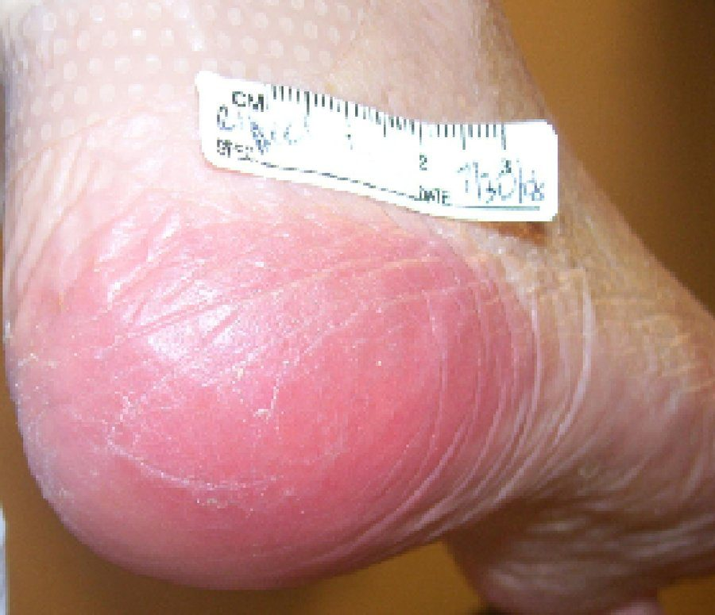  Stage I pressure ulcer. The skin is intact — the finding is erythema that fails to blanch under pressure, together with change in temperature, consistency, sensation and color. Everything after this stage involves broken skin. Source: PD II Derm - Beck.pptx, Slide 59. | 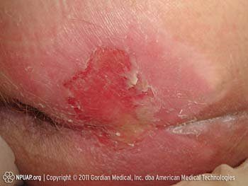  Stage II . Partial thickness skin loss involving epidermis, dermis or both. Shallow and open, with no necrosis of the tissue beneath. Source: PD II Derm - Beck.pptx, Slide 60. | 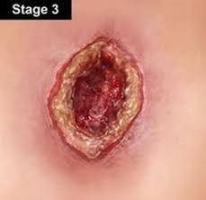  Stage III . Full thickness skin loss with necrosis of subcutaneous tissue. It may extend to, but not through , the underlying fascia (the tough sheet over the muscle). The slide says muscle; once muscle, bone or supporting structures are involved, it is stage IV. Source: PD II Derm - Beck.pptx, Slide 61.
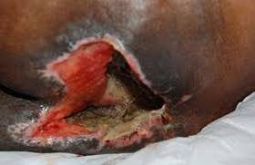
Stage IV . Full thickness loss with destruction of tissue, muscle and/or bone. Involvement of muscle, bone or supporting structures is the line between this and stage III. Source: PD II Derm - Beck.pptx, Slide 62.

Tinea infections, named by site: corporis (body) · pedis (foot) · barbae (beard) · cruris (groin) · capitis (scalp) · unguium (nails).
Infection | Appearance
Tinea pedis | Dry, scaling, or macerated fissuring of the interdigital spaces of the feet
Tinea corporis | Scaling, sharply demarcated round plaques with central clearing
Tinea capitis | Round scaling patches of alopecia with hairs broken off close to the scalp

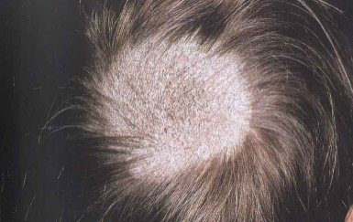  Tinea capitis — a round scaling patch of alopecia with hairs broken off close to the scalp. Both features matter: alopecia areata gives smooth patches with no scale, and trichotillomania gives neither. Source: PD II Derm - Beck.pptx, Slide 64. | 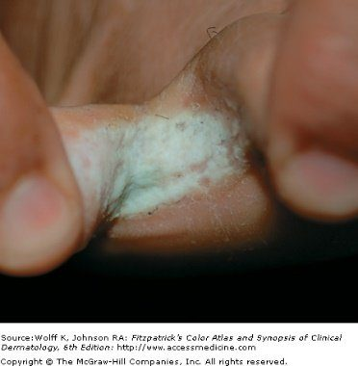  Tinea pedis — macerated fissuring of the interdigital spaces. It also presents dry and scaling; the web spaces are the constant. Source: PD II Derm - Beck.pptx, Slide 64. | 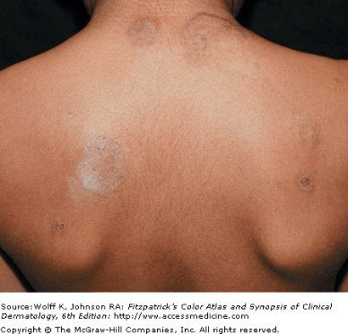  Tinea corporis — scaling, sharply demarcated round plaques with central clearing . The active advancing edge with a quiet middle is what earns it the name ringworm, and the configuration term for it is annular . Source: PD II Derm - Beck.pptx, Slide 64.

Malignancies of the skin.
Malignancy | Common site | Appearance
Basal cell carcinoma | Face | Translucent, pearly nodule with a depressed center and raised borders; may ulcerate. A non-healing ulcer is the other presentation
Squamous cell carcinoma | Face and other sun-exposed areas | Red scaling, crusting nodule or plaque that can ulcerate and bleed
Malignant melanoma | Changing nevi | Irregularly colored plaque with sharp notches and variation of pigment
Kaposi's sarcoma | Widely disseminated — legs, trunk, arms, neck, head | Starts as light colored lesions that coalesce into darker ones; dark blue-purple macules, papules, nodules and plaques. The most frequent neoplasm in patients with acquired immunodeficiency syndrome

Letter | Melanoma warning sign
A | Asymmetry or shape
B | Border irregularity
C | Color variation
D | Diameter larger than 6 mm
E | Evolving, elevation
F | Family history
G | Growing

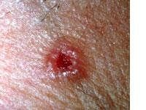  Basal cell carcinoma — a translucent, pearly nodule with a depressed center and raised borders . The face is the common site. A non-healing ulcer there should raise the same suspicion even without the pearly rim. Source: PD II Derm - Beck.pptx, Slide 67. | 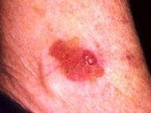  Squamous cell carcinoma — a red scaling, crusting nodule or plaque that can ulcerate and bleed. Face and other sun-exposed areas. Compare the surface with basal cell carcinoma: scaling and crusted here, translucent and pearly there. Source: PD II Derm - Beck.pptx, Slide 69. | 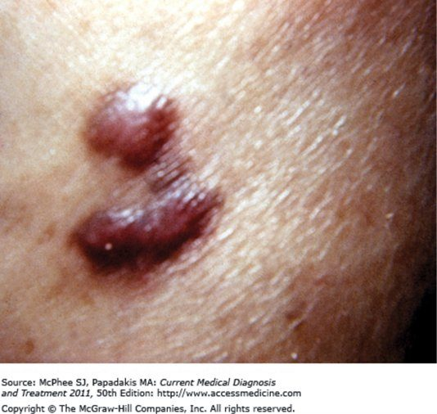  Kaposi's sarcoma — dark blue-purple macules, papules, nodules and plaques. Lesions start light colored and coalesce into darker ones, and they are widely disseminated across legs, trunk, arms, neck and head. The most frequent neoplasm in patients with acquired immunodeficiency syndrome. Source: PD II Derm - Beck.pptx, Slide 74.

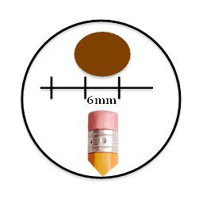  The D in the melanoma warning signs: diameter larger than six millimeters , which is about the width of a pencil eraser. The full list runs A asymmetry, B border irregularity, C color variation, D diameter, E evolving or elevation, F family history, G growing. Source: PD II Derm - Beck.pptx, Slide 71. | 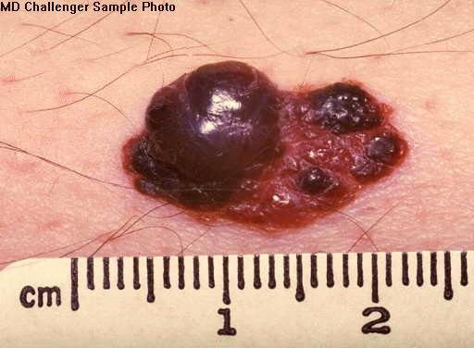  Malignant melanoma , with a ruler for scale. Every letter is visible at once: asymmetric, notched irregular border, marked variation in pigment, and well beyond six millimeters. Compare it against the changing nevus the history should have flagged. Source: PD II Derm - Beck.pptx, Slide 72.

Also tested
- Tinea of the groin. A tinea infection of the groin is tinea cruris; cruris denotes the groin, just as corporis denotes the body and capitis the scalp.
- Raised, shiny lesion on the auricle. A raised, shiny, slow-growing lesion with visible telangiectasia should raise suspicion of basal cell carcinoma, which is malignant, unlike the benign lumps.

2.7 · Objective d — Abnormal findings: hair and nails
★ PROFESSOR EMPHASIS
★ Professor emphasized
Exclamation point hairs in alopecia areata. “Hair loss in multiple round patchy areas, and this is important — you’ll see exclamation point hairs. Those are like a few follicles that are still trying … that should trigger in your mind, oh okay, alopecia areata, we gotta jump on this.”

Hair disorder | Findings
Alopecia | Diffuse, patchy or total hair loss. Note the distribution on inspection — that is what separates the causes
Androgenic alopecia | Male pattern baldness
Alopecia areata | Chronic inflammatory disease of hair follicles, associated with autoimmune disorders. Hair loss in multiple round patches, with “exclamation point” hairs
Trichotillomania | Caused by an urge to pull out hair, producing bald patches. Single or multiple; from a few square centimeters to the entire scalp
Hirsutism | Increased hair growth in women, in a male pattern of distribution
Lice | Tiny white ovoid granules — nits — adherent to hairs. A magnifying glass aids inspection

Three causes of patchy hair loss, told apart by what is left behind: tinea capitis leaves scaling patches with hairs broken close to the scalp; alopecia areata leaves smooth patches with exclamation point hairs; trichotillomania leaves patches from pulling, with neither scale nor exclamation point hairs.
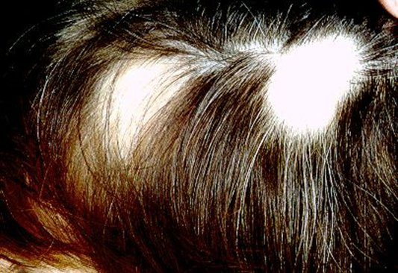
Alopecia areata — hair loss in multiple round patches. The scalp is smooth , with no scale, which separates it immediately from tinea capitis. Look at the margins for the tapered “exclamation point” hairs. It is a chronic inflammatory disease of the hair follicles and is associated with autoimmune disorders. Source: PD II Derm - Beck.pptx, Slide 79.
Nails. Inspect for shape, size, color, brittleness, hemorrhages, lines and grooves, clubbing, and pitting.
Finding | Description | Points toward
Koilonychia | Spoon-shaped concave nails; the nail plate thins and becomes inverted | —
Onycholysis | Painless separation of nail plate from nail bed, starting distally; several or all nails usually affected | Local irritation (chemical exposure, prolonged immersion in water), fungal infection, psoriasis, medications such as tetracycline, trauma
Nail pitting | Dystrophy of the nail plate; areas of small depressions or “pits” | —
Terry's nails | Proximal portion white, distal portion dark | —
Green nail | — | Pseudomonas infection
Brown–black nail | — | Melanoma
Subungual hematoma | Hemorrhage to the nail plate | —
Splinter hemorrhages | Hemorrhage of the distal capillary loop | —
Beau's lines | Transverse depressions | Halfway up the nail suggests an illness about 3 months ago
Mee's lines | Transverse lines | —
Clubbing | Angle between nail base and finger greater than 180°; end of finger becomes rounded and bulbous | —
Paronychia | Soft tissue infection around the nail, at the cuticle or nail fold. Acute: painful and purulent. Also occurs in chronic form | —

Beau's lines are a clock. The nail grows out at a roughly known rate, so a transverse depression halfway up dates the insult to about three months before the visit — which is the sort of finding that sends you back to the history with a specific date in mind.
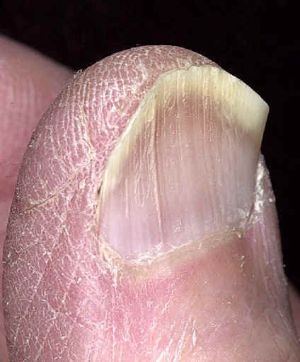  Koilonychia — spoon-shaped concave nails. The nail plate thins and becomes inverted; the concavity can be deep enough to hold a drop of water. Source: PD II Derm - Beck.pptx, Slide 85. | 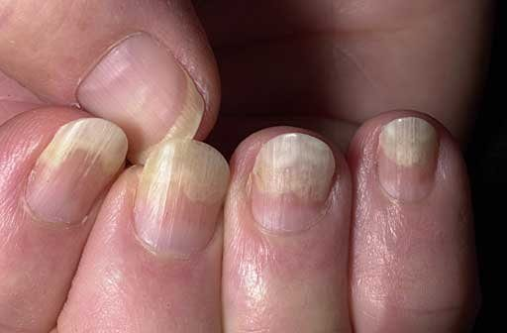  Onycholysis — painless separation of the nail plate from the bed, beginning distally and enlarging the free edge. Several or all nails are usually affected. Causes span local irritation, fungal infection, psoriasis, tetracycline and trauma. Source: PD II Derm - Beck.pptx, Slide 86. | 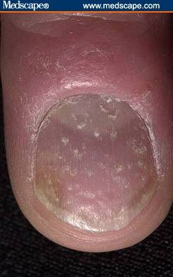  Nail pitting — dystrophy of the nail plate producing small depressions. Worth pairing in your head with onycholysis, since psoriasis produces both. Source: PD II Derm - Beck.pptx, Slide 87.
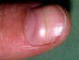
A transverse nail change. Beau's lines are transverse depressions you can feel; Mee's lines are transverse lines of color. Beau's lines date the insult — halfway up the nail corresponds to an illness about three months before the visit. Source: PD II Derm - Beck.pptx, Slide 90.

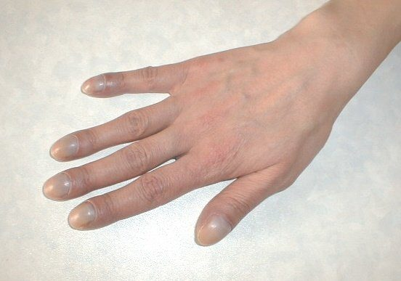  Clubbing — the angle between nail base and finger exceeds one hundred and eighty degrees , and the end of the finger becomes rounded and bulbous. Sight the finger from the side; the angle is the measurable part rather than the impression of bulbousness. Source: PD II Derm - Beck.pptx, Slide 91. | 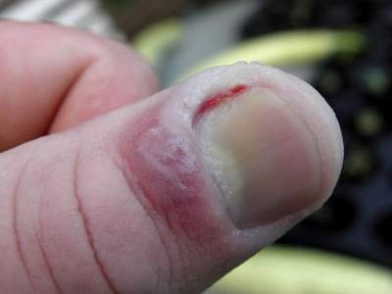  Acute paronychia — soft tissue infection around the cuticle or nail fold, painful and purulent. There is a chronic form too; pain and pus are what mark this one as acute. Source: PD II Derm - Beck.pptx, Slide 92.

Also tested
- Terminal versus vellus hair. Terminal hair is coarse and grows on the scalp and in the pubic, axillary and beard areas, while vellus hair is short and fine and covers the body.

2.8 · Objective e — Performing the examination
★ PROFESSOR EMPHASIS
★ Professor said you do NOT need this
Clinical pearls are context, not exam material. After explaining that shingles on the tip of the nose is a medical emergency because that dermatome carries the optic nerve, she drew the line explicitly: “I’m not going to test you on that — the testing is on this kind of stuff — but I’m just trying to give you the clinical level.”
“This kind of stuff” is the descriptive terminology and the examination itself. She added the pearl is worth knowing anyway because she believes it recurs on board exams — so learn it for practice, not for this exam.

The four principles are inspection, palpation, percussion and auscultation. That order holds for every body system except the abdominal examination, and some systems do not use all four.
Set-up | Detail
Equipment | Ruler · light source · magnifying lens · gloves for any open lesions
Patient | In a gown — so that hair, anterior and posterior body surfaces, palms and soles, nails and interdigital spaces can all be inspected
Light | Inspect the entire skin surface in good light, preferably natural light or artificial light that resembles it. Artificial light may distort skin tone

Six characteristics are assessed by inspection, palpation, or both:
Characteristic | Descriptive terms
Color | Increase or decrease in pigmentation · erythema/rubor · pallor · jaundice · cyanosis
Moisture | Dryness · sweating · oiliness
Temperature | Warmth · coolness — use the dorsal aspect of the hands
Texture | Roughness · smoothness
Mobility and turgor | See below
Lesions | Distribution, configuration, morphology, color, texture

 | Normal | Abnormal
Mobility | Skin lifts up with ease | Edema — reduced skin mobility
Turgor | Skin quickly resumes its shape | Dehydration — skin remains elevated

Central versus peripheral cyanosis is a two-organ distinction. Central cyanosis is often due to inadequate oxygenation in the lungs; peripheral cyanosis is usually due to inadequate circulation. Same color, different organ.
Hair and scalp. Inspect color, distribution and quantity; palpate for texture. Separate the hair into sections to observe the scalp, and inspect behind the ears and the occiput. The scalp should be clean, with no lesions, discolorations, flaking or parasites.
Source: PD II Derm - Beck.pptx (Valerie Beck, DMSc, PA-C), Slides 1–103, and the PAJ 5310 syllabus instructional objectives. Course texts: Bickley, Bates' Guide to Physical Examination and History Taking; Wolff & Johnson, Fitzpatrick's Color Atlas & Synopsis of Clinical Dermatology. All 43 figures are reproduced from the lecture slides and each is cited to the slide it came from.
Also tested
- Rubor. Rubor means erythema, or redness of the skin; the two terms are used interchangeably.
- Scalp examination. Separate the hair into sections in order to observe the scalp beneath, including behind the ears and the occiput.
- Skin assessment. Six characteristics are assessed by inspection, palpation or both: color, moisture, temperature, texture, mobility and turgor, and lesions; color and lesions begin with inspection and the remainder require touch.

3 · Advanced Ocular Medical History and Examination
INSTRUCTIONAL OBJECTIVES
Advanced Ocular Medical History and Examination
- Review the anatomical landmarks of the normal eye.
- Identify the anatomical landmarks of the normal eye.
- Demonstrate proficiency in performing a complete ocular examination.
- Define the elements in the medical history that aid in identifying ocular disorders.
- Define the elements of the physical examination that aid in identifying abnormal conditions of the eye.
- Identify specific symptoms related to abnormal conditions of the eye including the eyelids, sclera, cornea, and iris.
- Describe and identify expected visual exam findings when lesions along the visual pathway are present.
- Describe physical exam findings in non-visual painful conditions of the eye.
- Describe physical exam findings in non-visual painless conditions of the eye.
- Define common ocular findings in relation to certain disease states including hypertension, diabetes mellitus, increased intracranial pressure, and infection.

★ PROFESSOR EMPHASIS
★ What she took OUT of scope
Professor Beck removes slides out loud, and keeps to it. Six things she said she would not test are therefore not in the quizzes and are noted here only so you do not spend time on them:
- The named virus in viral conjunctivitis. “I'm not going to test you on it, but adenovirus …” — she uses it for the great-mimicker story.
- The exophthalmometer, its technique and its 20–22 mm figure. “I am not going to test you on the minutia of how to do that test … don't worry about it.” Recognizing exophthalmos IS in — her words were “about exophthalmos and how to recognize it”.
- The strabismus diagram. “This is just a visual … that you don't have to memorize.” Eso-, exo- and hypertropia as concepts stay in.
- The corneal reflection test. “We've already done this, so I'm not gonna test you on it … we already did that in PD1.”
- The Adie's pupil look-alike list (dysautonomia, Shy-Drager, diabetes, amyloidosis). “It's not on my test this time.”Adie's pupil itself IS in — “you should know Adie's pupil, that could be on my test.”
- The Latin expansions of OD, OS and OU. “I don't care if you remember Oculus Sinister or Dexter.” The abbreviations themselves ARE in — “those are terms that you must remember.”

3.1 · The history
Assess any eye complaint on four axes: time course, precipitating factors, palliative or exacerbating variables, and vision loss or visual deficits.
Finding | What it points to
Bilateral visual loss, especially sudden | A neurologic cause is likely rather than an eye one; gradual loss in both eyes is often cataract or similar eye disease
Multiple new flashes or floaters | Retinal tear or vitreous hemorrhage
A single floater | Probably benign
Rapid deterioration | Vascular causes
Gradual loss | Cataract and the like
Itching + excessive tearing | Allergic
Deep pain | Acute narrow angle glaucoma
Pain relieved by topical anesthetic | A surface problem — corneal injury feels better
Pain not relieved by topical anesthetic | A deeper source

Also ask: corrective lenses; acute or chronic eye problems such as glaucoma; eye medications such as antiglaucoma drops or topical antibiotics; and eye surgery history. Tetanus status matters in eye trauma, and after a chemical splash you must establish whether the fluid was acid or alkali. Beck singled out three systemic diseases: diabetes, hypertension and human immunodeficiency virus — the last because it will affect basically any etiology.
Also tested
- Chemosis. Chemosis is swelling and inflammation of the conjunctiva itself, not of the lids or the globe.
- Eye pain relieved by topical anesthetic. Relief suggests a surface problem such as a corneal injury, whereas pain that is not relieved may come from a deeper source.
- Hyperemia. Hyperemia is injection of the superficially visible vessels of the conjunctiva, episclera or sclera.
- Entropion and ectropion. Both affect the lower lid; entropion is inward folding and ectropion is outward turning.

3.2 · The symptom patterns
Pattern | Think
Acute, unilateral, painless | Retinal vascular occlusion, retinal detachment, vitreous hemorrhage, macular degeneration
Acute, unilateral, painful | Usually cornea and anterior chamber: corneal abrasion or ulcer, uveitis, traumatic hyphema, acute narrow angle glaucoma
Acute, bilateral, painful | Thermal, radiation or chemical exposure
Gradual, painless | Simple glaucoma or cataract

Eye pain, qualified: with blinking → corneal abrasion or foreign body · gritty → conjunctivitis · with photophobia → iris inflammation · with headache → acute narrow angle glaucoma · on eye motion → optic neuritis · with temporal pain → temporal arteritis.
Discharge: watery or mucoid → allergic or viral; purulent → bacterial.
★ PROFESSOR EMPHASIS
★ “Very important to commit to memory”
Diplopia and the cranial nerves. HORIZONTAL — images side by side — means a palsy of cranial nerve III or VI. VERTICAL — images on top of each other — means a palsy of cranial nerve III or IV.
Her shortcut: “three for both of those” — the third nerve can cause either pattern, but double vision can also come from the sixth nerve alone (images side by side) or the fourth nerve alone (images on top of each other).
Diplopia otherwise means faulty alignment or a neurological problem — brainstem or cerebellar lesions, or weakness of one or more extraocular muscles. Look for a compensatory head posture.

Also tested
- Eye discharge. Purulent discharge suggests a bacterial infection, while watery or mucoid discharge suggests allergy or a virus.
- Excessive tearing or dryness. Excessive tearing or dryness comes from obstruction in the lacrimal apparatus or from Sjogren's syndrome.

3.3 · Inspection
Order of the examination: inspection → external examination → cornea without light, lens, pupils → visual acuity, the vital sign of the eye → visual fields → ocular motility → pupillary reactions, checked BEFORE dilating → corneal reflection → special tests → slit lamp → ocular pressure → direct ophthalmoscopy.
NOTE
In trauma, do not palpate the globe. And from the common-mistakes list: failing to look in both eyes, to examine the cornea and lens, to test acuity adequately, to identify a field defect, to evaluate all fundal structures, to recognize a ruptured globe (or placing too much pressure on one), to treat multiple floaters or new flashes as a possible detachment, to document adequately, to recognize an infectious red eye before prescribing a topical steroid, and to differentiate preseptal from orbital cellulitis — because the latter can lead to death.

Finding | Meaning
Scaly eyebrows | Seborrheic dermatitis
Lateral sparseness of the eyebrows | Hypothyroidism
Ptosis | Myasthenia gravis, oculomotor nerve damage, sympathetic damage (Horner). Senile ptosis is weakened muscle, relaxed tissue and the weight of herniated fat. May be congenital
Hordeolum | Painful infection at the lid's edge
Chalazion | Chronic, non-painful, meibomian — generally NOT at the margin; points inside the lid
Xanthelasma | Raised yellowish plaques along the nasal lid — consider lipid disorders
Ectropion / entropion / trichiasis | Out-turned lid / in-turned lid / posteriorly misdirected lashes
Yellow sclera | Liver disease
Blue sclera | Osteogenesis imperfecta

Proptosis: stand behind the seated patient and look down from above, drawing the lid slightly upward to compare the corneas against the lower lids. Causes: retrobulbar hemorrhage, orbital cellulitis, orbital tumor, Graves disease.
Nasolacrimal duct obstruction test: patient looks up; press on the lower lid near the medial canthus, just inside the bony rim, to compress the sac; look for fluid regurgitating from the puncta. Mucopurulent fluid means obstruction. Avoid the test if the area is significantly inflamed or tender.
Everting the upper lid to find a foreign body: patient looks down and relaxes; raise the lid so the lashes protrude, grasp them and pull down and forward; place a stick at least 1 cm above the lid margin at the upper border of the tarsal plate and push down as you raise the lid edge. Do not press on the eyeball. Never evert if globe rupture is suspected.
★ PROFESSOR EMPHASIS
★ “Be very familiar with that chart”
She singled this out: “I actually do genuinely think it's important that you are very familiar with that chart … it helps you compare and contrast the common important eye conditions.” On the slide it is a picture of the table, so it does not appear in any text copy of the deck — it is written out here.
 | Conjunctivitis | Corneal injury / infection | Acute iritis | Glaucoma | Subconjunctival hemorrhage
Pattern of redness | Conjunctival injection: diffuse dilation, redness maximal peripherally
Pain | Mild discomfort rather than pain | Moderate to severe, superficial | Moderate, aching, deep | Severe, aching, deep | Absent
Vision | Not affected except temporary mild blurring from discharge | Usually decreased | Decreased | Decreased | Not affected
Ocular discharge | Watery, mucoid or mucopurulent | Watery or purulent | Absent | Absent | Absent
Pupil | Not affected | Not affected unless iritis develops | May be small and, with time, irregular | Dilated, fixed | Not affected
Cornea | Clear | Changes depending on cause | Clear or slightly clouded | Steamy, cloudy | Clear
Significance | Bacterial, viral and other infections; allergy; irritation | Abrasions and other injuries; viral and bacterial infections | Associated with many ocular and systemic disorders | Acute increase in intraocular pressure — an emergency | Often none. May result from trauma, bleeding disorders, or a sudden increase in venous pressure such as coughing

When the injection pattern does not help, the chart gives four backup clues to catch the dangerous three: pain, decreased vision, unequal pupils, and a less than perfectly clear cornea.

Also tested
- Nodular episcleritis. It can be seen in rheumatoid arthritis and lupus erythematosus.
- Blepharitis. This common eye inflammation is associated with bacterial infection and atopic dermatitis.
- Diffusely red eye. Corneal injury, acute iritis and glaucoma can look diffusely red rather than showing ciliary injection; pain, decreased vision, unequal pupils and a hazy cornea (less than perfectly clear) mark these more serious disorders.
- Xanthelasma. These raised yellowish plaques lie along the nasal portions of one or both eyelids; consider lipid disorders.
- Subconjunctival hemorrhage and globe rupture. Globe rupture is more likely in trauma, and when the hemorrhage encircles the entire cornea.
- Red eye with diffuse redness. Conjunctivitis gives diffuse conjunctival redness maximal peripherally, with vision affected only by mild blurring.
- Subconjunctival hemorrhage findings. Pain is absent, vision and pupil are unaffected, there is no discharge, and the cornea is clear.
- Painless red eye. Subconjunctival hemorrhage is the cause of red eye with absent pain and discharge, an unaffected pupil and vision, and a clear cornea.

3.4 · Acuity, fields and motility
OD is the right eye, OS the left, OU both — she called these “terms that you must remember”. 20/200 means that at 20 feet the patient reads print a normal eye reads at 200 feet; the larger the second number, the worse the vision. If the patient cannot read the chart, document counting fingers, hand motion, or light perception.
Pinhole test: the pinhole blocks the scattered outer rays and lets through only a narrow central beam, which shrinks the blur, so vision improves if the problem is a refractive error. If the deficit is not improved, consider cataract, optic nerve disease, or retinal disease.
Confrontation fields are best done with both the static finger wiggle test (arms' length, hands two feet apart lateral to the ears, wiggling fingers brought slowly into view, testing each quadrant) and the kinetic red target test (a 5 mm red-topped pin moved inward from beyond each quadrant, asking when it first appears RED). A temporal defect in one eye should prompt testing for a nasal defect in the other. The normal blind spot sits 15 degrees temporal to the line of gaze and is enlarged in glaucoma, optic neuritis and papilledema.
Nystagmus: fine rhythmic oscillation. A few beats on lateral gaze is normal — bring the finger back into binocular vision, and if it persists there, consider a neurologic condition. Lid lag — sclera visible above the iris on downgaze — is most often hyperthyroidism. The cover-uncover test reveals slight muscle imbalance not otherwise seen.
Also tested
- Unperformed examination. History and examination findings may never be made up. If part of the examination was not performed, the note documents why it was not done.
- Eye abbreviations. OD is the right eye, OS the left eye and OU both eyes.
- Kinetic red target test. Move a 5 mm red-topped pin inward from beyond the boundary of each quadrant along a line bisecting the meridians, and ask when the pin first appears red.
- Pinhole test. It distinguishes a refractive error from other causes: a pinhole blocks the scattered outer rays and lets through only a narrow central beam, so a deficit it improves is refractive; if not, consider cataract or nerve disease.
- Static finger wiggle test. At arm's length with hands two feet apart beside the ears, wiggling fingers are brought slowly inward until seen, quadrant by quadrant.

3.5 · The pupils
A difference of half to one millimeter is common, and anisocoria is benign if the reactions are normal. Abnormal: a difference greater than 1 mm, or a poorly reactive pupil.
NOTE
Red on her slide, and she said so: an acute, significantly dilated pupil is a medical emergency, particularly with headache or other neurologic signs — uncal herniation or a posterior communicating artery aneurysm causing a third nerve palsy.

Swinging light test. Indication: anisocoria. Normal — direct and consensual constriction. Abnormal: paradoxical DILATION of both pupils when the light swings to the affected eye, with an intact consensual reflex. That is a relative afferent pupillary defect — a Marcus Gunn pupil — and the lesion is the OPTIC NERVE. The mechanism: the afferent stimulus on that side is reduced, so the efferent signal to both pupils falls and a net dilation results.
 | Pupil | Light | Near | Other
Adie's tonic | Large, regular, usually unilateral | Severely reduced and slowed, or absent | Present but very slow | Degeneration of the ciliary ganglia and postganglionic parasympathetic fibers; slow accommodation blurs near vision
Argyll Robertson | Small, unequal, irregular | No reaction | Constricts | “Accommodates but doesn't react.” Classically tertiary syphilis (neurosyphilis); diabetes and Lyme disease can cause a similar pupil, and today diabetes is the more common cause of a similar picture. Mydriatics dilate it only incompletely
Horner syndrome | Small (miosis) | Ptosis, anhidrosis of the ipsilateral face. Sympathetic supply to the pupil and levator interrupted. Congenital form: the involved iris is lighter (heterochromia)
Oculomotor palsy | Dilated in a compressive palsy; often spared in a diabetic (ischemic) palsy | Ptosis and lateral deviation almost always present

The pupil in an oculomotor (third nerve) palsy: in a compressive palsy the pupil is dilated and fixed to both light and near effort, with ptosis and lateral deviation almost always present; in a diabetic (ischemic) palsy the pupil is often spared.
Once local eye disease is excluded, only three causes of a dilated pupil remain: compression or other lesion of cranial nerve III; parasympathetic denervation from a ciliary ganglion lesion (Adie's); and pharmacologic block of the pupillary sphincter.
Oblique lighting and the crescent shadow: shine from the temporal side and look for a shadow on the medial iris. No shadow is normal — the iris is flat, the angle open. A shadow means the iris is bowed forward, a narrow angle, and a raised risk of narrow-angle glaucoma. A corneal scar is a superficial grayish-white opacity; do not confuse it with a cataract, which lies deeper and is seen only through the pupil.
Also tested
- Swinging light test. It assesses functional impairment of the optic nerve and the integrity of the visual pathways, and it is indicated for anisocoria.
- Crescent shadow test. Oblique lighting assesses the depth of the anterior chamber angle. A shadow on the medial iris means it is bowed forward into a narrow angle, raising the risk of narrow-angle glaucoma.
- Abnormal pupil findings. A difference in size greater than 1 mm is abnormal, as is a pupil that reacts poorly to direct light.
- Pupillary constriction in the near reaction. It is mediated by the oculomotor nerve; convergence and accommodation happen alongside it but are not part of it.

3.6 · Fundoscopy
Do NOT dilate if serial neurologic examinations are required, in elderly patients who have not had cataract surgery (a thick natural lens can crowd the angle), or if acute angle-closure glaucoma is suspected. (The slide says patients who have had cataract surgery; after surgery the artificial lens leaves more room.) If you do dilate, document the time and the agents used.
 | Color | Disc | Cup / vessels
Normal | Yellowish-orange to cream | Sharp margin | Cup central or slightly temporal, diameter less than half the disc
Papilledema (raised intracranial pressure) | Pink | Swollen, margins blurred | Cup not visible; loss of vessel pulsations
Glaucomatous cupping | — | — | Cup enlarged, more than half the disc; vessels sink in and around the disc
Optic atrophy | White | — | Tiny disc vessels absent. Seen in optic neuritis, multiple sclerosis, temporal arteritis

Also tested
- Dilated pupils. Document the time of dilation and the agents used; a weak mydriatic reverses in 4 to 6 hours.
- Normal fundus and disc. The fundus is yellowish-orange to cream in color, with small disc vessels, a sharp disc margin, and a cup located centrally or slightly temporal with a diameter normally less than half the disc.

3.7 · Trauma and disposition
Mechanism matters, and so does the size of the object: larger objects transfer most of their energy to the orbital rim, while smaller ones may strike the globe directly.
Injury | Findings
Orbital (blow-out) fracture | Sunken eye, hypoesthesia of the infraorbital area (infraorbital nerve), diplopia particularly on UPWARD gaze, decreased motility, sometimes an ipsilateral nosebleed. Refer to ophthalmology or oral and maxillofacial surgery
Enophthalmos | Sunken eye with ecchymosis, point tenderness and a palpable step-off at the orbital rim. Observe from above the head looking down
Zygomatic fracture | Flattening of the malar eminence, best seen from behind the seated patient. Edema and ecchymosis of temple or infraorbital area, palpable step-off, infraorbital hypoesthesia. Pain on opening the mouth, because temporalis passes medial to the arch and inserts on the mandible
Hyphema | Blood in the anterior chamber, usually blunt trauma. Check acuity, pupils (a crescent-like iris defect if torn; reduced reactions if the sphincter is damaged), the red reflex, the intraocular pressure, and slit lamp
Corneal abrasion | Blunt trauma — fingernail, contact lens. Significant pain and photophobia, blepharospasm, foreign body sensation, tearing. Evert the upper lid: a foreign body in the upper tarsal conjunctiva scratches the cornea with every blink. A hazy cornea suggests bacterial infection. Topical anesthetic gives immediate relief but is for diagnosis, not treatment
Corneal ulcer | Pain, photophobia, tearing, reduced vision. Red eye, circumcorneal injection, purulent or watery discharge. Herpes simplex ulcers are not very painful. An ophthalmoscope at +40 diopters may reveal it, but fluorescein is more sensitive for early ulcers

Fluorescein: orange dye instilled, blue light — taken up by areas of cornea devoid of epithelium.
★ PROFESSOR EMPHASIS
★ “Please know this list”
Her reason: “because you're going to be making those dispos.”
EMERGENT — ophthalmology or the emergency department immediately | URGENT — ophthalmology follow-up in a day or less
Sudden vision loss · retinal artery occlusion · chemical burns · rupture · acute angle-closure glaucoma · vitreous hemorrhage | Acute glaucoma · orbital cellulitis · corneal ulcer or abrasion · retinal detachment · macular edema or hemorrhage · hyphema

Also tested
- Ophthalmoscope for corneal ulcer. Set at +40 diopters, it in effect fixes a ten times magnifying lens for viewing a corneal ulcer. Fluorescein staining is more sensitive for early ulcers.
- Hazy cornea in suspected abrasion. If the cornea is hazy in a suspected abrasion, a bacterial infection should be suspected.
- Topical anesthetic in corneal abrasion. It brings immediate relief of an abrasion, but use it for diagnosis, not as a treatment.
- Everting the upper lid in corneal abrasion. A foreign body embedded in the upper tarsal conjunctiva can repeatedly scratch the cornea as the eye opens and closes.
- Sunken eye from orbital floor fracture. Look for ecchymosis, point tenderness and a palpable step-off around the orbital rim; it is best observed from above the head looking down toward the eyes.
- Immediate ophthalmology referral. A chemical burn is emergent: irrigate the eye at once, then send the patient to ophthalmology immediately, as with rupture and sudden vision loss.
- Zygomatic fracture. Findings are flattening of the malar eminence best seen from behind the seated patient looking down, edema and ecchymosis of the temple or infraorbital area, and a palpable step-off on palpating the zygoma.

4 · Advanced ENT History and Examination
INSTRUCTIONAL OBJECTIVES
Advanced ENT History & Exam
- Describe and identify the anatomical landmarks of the head, ear, nose, and throat.
- Demonstrate proficiency in performing a head, ears, nose, and throat physical examination.
- Define the elements in the medical history that aid in identifying abnormal conditions of the head, ears, nose, and throat.
- Define the elements of the physical examination that aid in identifying abnormal conditions of the head, ears, nose, and throat.
- Demonstrate appropriate physical examination techniques when differentiating between conductive and sensorineural hearing loss.

★ PROFESSOR EMPHASIS
★ Know for Exam — with a number attached
The tuning fork tests are worth three points. The video played in class said it outright: “the Weber and the Rinne tests are both high yield … the difference between sensorineural hearing loss and conductive hearing loss is also high yield … it will be three points on test day if you dedicate the necessary amount of time.” Very little else in this course comes with a stated mark value.
Two mnemonics were taught aloud, and both are worth keeping:
- “Rinne is under the pinna.” The outside of the ear is the pinna; the Rinne fork goes on the mastoid, under it. So anything placed under the ear is Rinne.
- “Weber tells you whether.” “See what I did there — I replaced the word whether with Weber.” Weber tells you whether it is the right ear or the left.
And the lecturer added the half the video left out [56:52]: the video worked the sensorineural case, so he supplied the conductive one — “if it’s conductive it’s going to go to the one that … is blocked.”

★ PROFESSOR EMPHASIS
★ The practical — name it while you do it
He was explicit, twice, that the physical examination is graded on naming the structure as you touch it. On the node chains [26:18]: “I need for you to know when you’re pressing preauricular … when you’re telling me I’m doing preauricular I need to see that. I need to see the cervical nodes. I need to know where you’re putting your finger.” And on the inspect-and-palpate sequence [27:42]: “tenderness, deformity, any masses — learn those, memorize those, you need to know them, because that’s going to be part of your test.”
Earlier, on pointing generally [25:40]: “make sure that you point to what it is … because that’s how I’m going to grade you. If you’re just putting your hands all over the place, that doesn’t mean anything.”

4.1 · The ear history
It opens with one question — “Have you had any trouble with your ears?” — and then splits four ways: pain, discharge, hearing, and the vertigo and tinnitus group.
Pain is the one that misleads, because the ear may be entirely normal. Ear pain is frequently referred, and the sources to ask about are the temporomandibular joint, the teeth and the cervical spine — carried by cranial nerves V, VII, IX and X. Four sensory nerves supplying one small structure is exactly why disease well away from the ear arrives as otalgia. He made the wider point on history technique here [5:32]: “the first answer is you don’t go with the first answer. You’ve got to keep asking” — and then the reason: “if you’ve got the wrong history, that means you’re going to do the wrong physical, wrong physical, wrong diagnosis, wrong diagnosis, wrong treatment.”
Also ask about associated symptoms — fever, sore throat, cough, upper respiratory infection — and keep otitis media, otitis externa and Eustachian tube dysfunction in mind as the local causes. The history structure is OPPQRST: onset, palliative, provoking, quality, radiation, site, timing.
Discharge is characterized by color, consistency and quantity, and the possibilities are cerumen, blood, water or purulent fluid. It points to otitis externa, otitis media with perforation, or trauma and foreign bodies.

4.2 · Hearing, tinnitus and “dizziness”
“How is your hearing?” then “Do you have difficulty understanding people when they speak?” The second question is the useful one, because it separates volume from clarity:
What the patient reports | What it suggests
Trouble understanding speech; others seem to mumble | Sensorineural
Worse in noisy environments | Sensorineural
Noisy environments may help | Conductive

Why noise helps in conductive loss is worth understanding rather than memorizing: the block does not change the balance of speech and noise, but everyone raises their voice over the background, so the louder speech gets through even though the noise is also turned down.
Ask about medications: aminoglycosides, aspirin, non-steroidal anti-inflammatories, quinine and furosemide. All five are common, and none of them will be volunteered.
Tinnitus is sound with no external source. Unexplained tinnitus stands alone; tinnitus with hearing loss and vertigo is Ménière disease. Vertigo is the perception of rotation, spinning or tilting, and points to inner ear problems — labyrinthitis, cranial nerve VIII, benign positional vertigo, Ménière.
★ PROFESSOR EMPHASIS
★ Professor emphasized
“Dizziness” means nothing until the patient explains it. The deck calls it very important to have the patient explain this term, and it splits four ways:
- Vertigo — spinning sensation
- Presyncope — faint or lightheaded
- Disequilibrium — unsteadiness or imbalance
- Psychiatric — anxiety, depression, alcohol or other substances
Four patients can use one word for four unrelated problems. Nothing else in the ear history turns on a single clarifying question this much.

Also tested
- Dizziness. When a patient says they are dizzy, the history must separate vertigo, presyncope, disequilibrium and psychiatric causes; the word means nothing until the patient explains it.

4.3 · The vertigo comparison
Read this table down the duration column first, then check hearing and tinnitus. The two together narrow the list a lot, and neurologic signs then separate central vertigo.
Type | Onset | Duration and course | Hearing | Tinnitus | Other
Benign positional vertigo  peripheral | Sudden, on rolling onto the affected side or tilting the head up | Seconds to under a minute. Lasts a few weeks; may recur | Not affected | Absent | Sometimes nausea, vomiting, nystagmus
Vestibular neuronitis (the slide adds “acute labyrinthitis”, but labyrinthitis proper also brings hearing loss and tinnitus)  peripheral | Sudden | Hours to two weeks. May recur over 12–18 months | Not affected | Absent | Nausea, vomiting, nystagmus
Ménière disease  peripheral | Sudden | Several hours to a day or more. Recurrent | Sensorineural — recurs, eventually progresses | Present, fluctuating | Pressure or fullness in the affected ear; nausea, vomiting, nystagmus
Drug toxicity  peripheral | Insidious or acute — loop diuretics, aminoglycosides, salicylates, alcohol | May or may not be reversible; partial adaptation occurs | May be impaired | May be present | Nausea, vomiting
Acoustic neuroma  peripheral | Insidious, from cranial nerve VIII compression | Variable | Impaired, ONE side | Present | May involve cranial nerves V and VII
Central vertigo | Often sudden — brainstem lesion, atherosclerosis, multiple sclerosis, vertebrobasilar migraine, transient ischemic attack | Variable, from brief spells (as in a transient ischemic attack) to constant vertigo lasting days (as in a stroke) | Not affected | Absent | Other brainstem deficits — dysarthria, ataxia, crossed motor and sensory deficits

Three things to take from the table. First, hearing is the great divider: of the six, only Ménière, drug toxicity and acoustic neuroma touch it. Second, positional vertigo is defined by how brief each episode is, and the episode length and the illness length are different numbers — seconds for the attack, weeks for the condition. Third, central vertigo has no ear symptoms and plenty of neurological ones, which is the pattern rather than any single feature.
Also tested
- Ménière disease. Its vertigo is accompanied by pressure or fullness in the affected ear, with fluctuating tinnitus and a sensorineural loss that recurs and eventually progresses.

4.4 · The ear examination
Inspect and palpate before the otoscope: the auricles, the mastoid, and the tragus. Tenderness localizes disease before anything enters the canal.
Otoscopy technique, and every element earns its place:
Step | Why
Pull the auricle up, back and away from the head | Straightens the canal. The view is only as good as the alignment
Use the LARGEST speculum that will fit | A small one is tempting, but it leaks — and insufflation needs a seal
Ulnar aspect of the hand contacts the patient | Anchors the instrument to the head, so a sudden movement takes the otoscope with it rather than into the canal
Insufflate | Reduced mobility means effusion or a thickened membrane

Insufflation, done properly. Check the otoscope for leaks after the speculum is attached: place a finger over the speculum tip and squeeze the bulb — you should feel the pressure build if there is no leak. Insert, confirm the seal, then apply quick, firm but gentle pressure and watch the membrane. Without a seal the test is not merely harder, it is inaccurate, and an immobile-looking drum may just be a leaking instrument.
“You have to see hundreds of normal before you see anything abnormal” [31:55]: “you’ve got to get used to seeing the normal. This is what a normal looks like … and then the abnormal will hit you in the face.” He repeated it at the eardrum slide — “know what normal looks like … normal, normal, normal.”
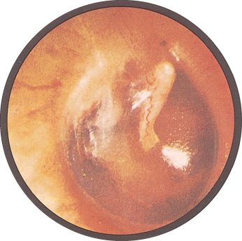
A normal tympanic membrane. “You have to see hundreds of normal before you see anything abnormal” — find the handle of the malleus and the cone of light here, so you notice when they are missing. Slide 27
Also tested
- Microtia. It is an abnormally small auricle, congenitally underdeveloped, and is grouped with atresia among the congenital deformities.
- Tympanic membrane mobility. Reduced mobility on insufflation points to an effusion behind the membrane or to a thickened tympanic membrane.
- Hard nodules on the auricle. Hard nodules made of uric acid crystals are tophi, indicating chronic tophaceous gout; they are deposits rather than growths, and on the ear they point to long-standing disease.

4.5 · What you find in the canal and on the drum
In the canal. Cerumen, and foreign bodies — the deck's list is Q-tips, beads, pencil lead, styrofoam, crayons, popcorn and tympanostomy tubes, under the heading “if it fits…”.
Finding | Appearance
Acute otitis externa | Canal swollen, narrow, moist, pale, TENDER; may be erythematous
Chronic otitis externa | Canal skin thickened, red, ITCHY
Perforation | Central — does not extend to the margin. Marginal — involves the margin. Usually secondary to otitis media, and there may be drainage through it
Tympanosclerosis | Hyaline deposit in the membrane, after severe otitis media or a healed perforation, including grommet sites. Usually not clinically significant
Serous effusion | Amber fluid, sometimes with bubbles. Follows an upper respiratory infection or a change in atmospheric pressure
Otitis media | Red, landmarks LOST, BULGING, with purulent effusion. Streptococcus pneumoniae and Haemophilus influenzae
Bullous myringitis | Painful hemorrhagic vesicles on the membrane or canal. May be viral or bacterial

Acute against chronic otitis externa is pain against itch, and swelling against thickening. The distinction is easier from the history than from the picture.
Bulging is graded, not binary. The deck carries a four-panel series, and the useful thing about it is the middle two — a mildly bulging drum still has landmarks you can pick out, and the point at which they disappear is the point the effusion has become convincing.
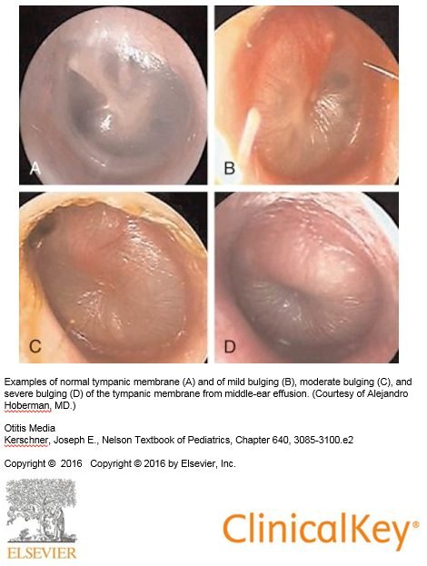
Bulging is graded, not binary: A normal, B mild, C moderate, D severe , from middle ear effusion. Watch the landmarks disappear as it progresses — that is the transition that makes the effusion convincing. Slide 32

4.6 · Hearing screening and the tuning fork tests
Whispered voice test. Stand two feet BEHIND the patient — which removes lip reading — occlude the ear not being tested, and whisper a three number or letter sequence twice. Normal is three or more of six correct; abnormal is four of six incorrect. The other bedside screens are finger rub and a watch.
 | Conductive loss | Sensorineural loss
Pathophysiology | External or middle ear disorder impairs conduction to the inner ear. Foreign body, otitis media, perforation, otosclerosis of the ossicles | Inner ear disorder involving the cochlear nerve and impulse transmission to the brain. Loud noise, inner ear infection, trauma, acoustic neuroma, congenital and familial disorders, aging
Usual age of onset | Childhood and young adulthood, up to about 40 | Middle or later years
Canal and drum | Abnormality usually VISIBLE — except in otosclerosis | Problem not visible
Effect on sound | Little effect. Hearing seems to improve in a noisy environment. Voice remains SOFT, because the inner ear and cochlear nerve are intact | Higher registers lost, so sound may be distorted. Hearing worsens in noise. Voice may be LOUD, because hearing is difficult
WEBER (fork at vertex) | Lateralizes to the IMPAIRED ear — room noise is not well heard, so detection of vibration improves | Lateralizes to the GOOD ear — damage impairs transmission on the affected side
RINNE (meatus, then mastoid) | Bone ≥ air. Vibration through bone bypasses the blocked external or middle ear to reach the cochlea | Air > bone. The damaged cochlea or nerve transmits poorly however the vibration arrives, so the normal pattern prevails

Voice volume is a feedback loop, and it is the bedside sign people forget. A patient who cannot hear themselves speaks up; a patient whose cochlea is intact hears their own voice by bone conduction perfectly well and has no reason to.
The Rinne result in sensorineural loss is the counterintuitive one. Rinne compares two routes to the same cochlea. Damage the cochlea and both routes degrade together, so the ratio between them is unchanged — a “normal” Rinne in an ear that hears badly. That is not a failure of the test; it is the test working.
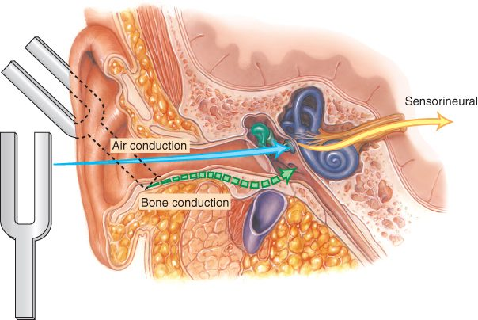
The two routes the tuning fork tests compare. Air conduction goes through canal, drum and ossicles; bone conduction goes straight through the skull, bypassing all of it. Conductive loss blocks one route; sensorineural loss degrades what lies beyond both. Slide 5
★ PROFESSOR EMPHASIS
★ Worked example from class
Rinne on the right: heard better in the air — normal. Weber: heard better in the right ear. Which ear has sensorineural loss?
The LEFT. The normal Rinne rules out a conductive problem on the right, and Weber lateralizes away from a sensorineural lesion — so hearing it on the right puts the damage on the left.
What the tuning forks CANNOT do, which is on the slide and easy to skip: they do not distinguish normal from bilateral sensorineural loss, and they do not distinguish normal from mixed conductive and sensorineural loss. Both tests work by comparing — one side against the other, or one route against the other. A loss that is symmetrical, or that hits both routes, leaves the comparison looking normal.

Also tested
- Weber test. The base of the fork is placed on the top of the head or mid-forehead. The test evaluates unilateral hearing loss by lateralization.
- Exostoses. These are benign bony growths in the ear canal. They narrow the canal mechanically, causing conductive hearing loss.
- Viral causes of sensorineural hearing loss. Rubella and cytomegalovirus both damage the inner ear, and both matter most when the exposure was congenital.
- Tuning fork hearing tests setup. Use a 512 hertz fork, the smaller one, in a quiet room. The frequency sits in the speech range and rings long enough to compare two positions.
- Conductive causes of hearing loss. These include cerumen, foreign bodies, effusions, exostoses, tumors and tympanic membrane perforation, all of which obstruct or load the external or middle ear.
- Normal Weber result. The sound is heard at the midline, or equally in both ears, with no lateralization to report.
- Rinne in conductive hearing loss. Bone conduction is equal to or greater than air conduction, because vibrations through bone bypass the impaired external or middle ear to reach the cochlea.
- Rinne test technique. Place the fork on the mastoid until the sound stops, then beside the canal, and ask whether it is still heard.
- Rinne in sensorineural hearing loss. Air conduction is still greater than bone conduction, so the normal pattern prevails, because the inner ear or cochlear nerve fails however the vibrations arrive.
- Frequency pattern of presbycusis. It is a higher frequency loss, so the complaint is about clarity rather than volume, because the high registers carry the consonants.

4.7 · The nose and sinuses
Anatomy first, because the drainage explains the disease [0:16]. Three turbinates — superior, middle and inferior — and the maxillary sinus drains at the middle turbinate. The Eustachian tube opens into the back of the nose (the nasopharynx), which is why “everything comes together, ear, nose and throat”; tears also drain into the nose through the nasolacrimal duct, which is why you get congestion when you cry.
And the warning that goes with it [0:46]: the sinuses and the top of the nose sit just beneath the base of the skull, so infection there can spread upward toward the brain. “So you have to be careful. Any infection in this area, you have to be a little more aggressive.” (The lecturer put it as “the roof of the mouth is the floor of your brain”; anatomically the roof of the mouth is the floor of the nose.)
History: onset and duration, sick contacts and recent travel, recent dental work — because dental work can affect the maxillary sinuses sitting directly above the upper tooth roots — and seasonal or environmental triggers pointing to allergic rhinitis. Facial pain or tenderness points to sinusitis. Ask about medications: duration, efficacy, and specifically rhinitis medicamentosa and cocaine. Ask whether the sense of smell is affected.
Epistaxis is caused by digital trauma or other trauma, inflammation, dry mucosa, foreign body, or tumor. Recurrent bleeding, or bleeding and bruising elsewhere, suggests a systemic problem — one nosebleed is local until a pattern says otherwise.
Examination step | What you are looking for
Patency | Occlude one nostril and breathe in. UNILATERAL obstruction → foreign body, tumor, deviated septum
Masses | Polyps — associated with allergic rhinitis, aspirin sensitivity, asthma, chronic sinus infection, cystic fibrosis. Also cysts and tumors
Symmetry and deformity | Deviated septum, perforated septum, trauma
Discharge | Thick and purulent, thin and watery, or bloody. Note odor
Mucosa | Color, swelling, bleeding, ulceration. Red and swollen → VIRAL. Pale, bluish or red → ALLERGIC
Septum | Perforation — from trauma, surgery or drug use
Palpation | Press UP on the frontal sinuses avoiding the eyes; press UP on the maxillary sinuses
Transillumination | Dark room. Frontal: light up under the brow close to the nose. Maxillary: light down just below the inner corner of the eye, mouth open. Absence of glow → thickened mucosa or secretions. NOT sensitive or specific

Do not pull what you have not identified. He told a story against the nose examination [6:05]: a lesion everyone had called a polyp, which imaging showed to be brain tissue coming through. “You need to know what you’re looking at before you start pulling things. If you’re not sure, you’ve got to be careful.”
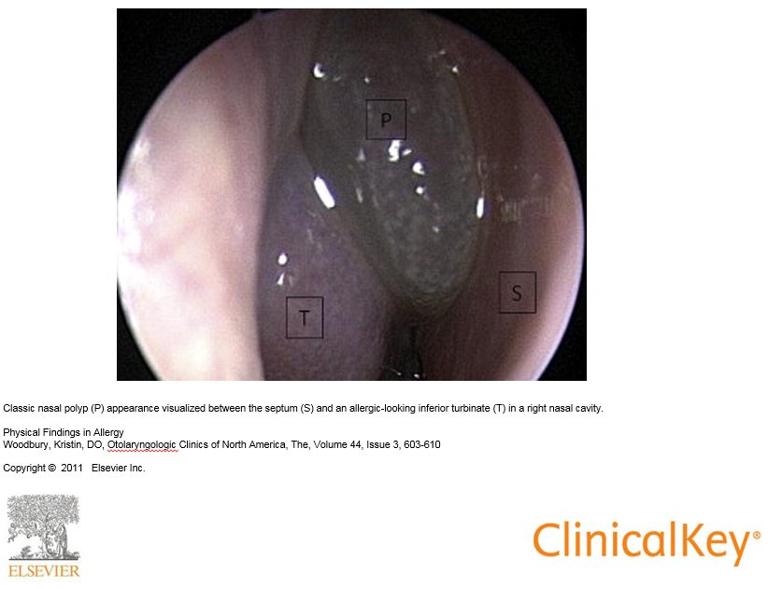
A nasal polyp ( P ) seen between the septum ( S ) and an allergic-looking inferior turbinate ( T ); polyps usually arise higher in the nose and hang down, while the swollen, boggy turbinate is fixed to the side wall. Seeing the two side by side is the point — a boggy turbinate mistaken for a polyp is the common error. Slide 59
★ PROFESSOR EMPHASIS
★ Professor emphasized
Acute sinusitis — three statements, and the second is the one people get wrong.
- Local tenderness, pain, fever and nasal discharge are suggestive, and purulent discharge is suggestive.
- The COLOR of the discharge is NOT diagnostic. He went further aloud [10:33]: purulent discharge “doesn’t need to be there … it’s not diagnostic”.
- Acute BACTERIAL sinusitis is unlikely with symptoms under seven days — “less than seven days, it’s not. It takes time to let it cook.”

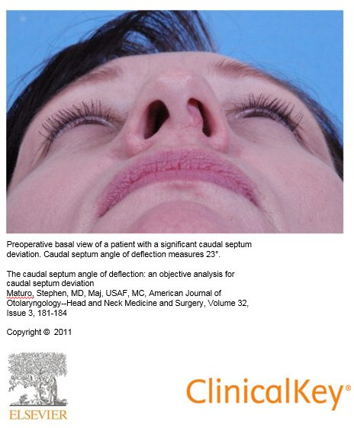
Basal view of a caudal septal deviation. The external appearance can be striking with little obstruction behind it, and the reverse is also true — test patency rather than trusting the profile. Slide 56
Septal hematoma is the nose finding that cannot wait. Injury disrupts the vessels and pulls the lining away from the cartilage, so blood collects between the two. It requires urgent drainage to prevent necrosis of the septal cartilage — the cartilage has no blood supply of its own and depends entirely on the lining that has just been stripped off it. His rule was broader than the nose [11:36]: “any time you have a septal hematoma — anywhere, in an ear, in the nose, whatever — that blood has to come out.”
A deviated septum may be entirely asymptomatic; he demonstrated pressing on an obvious external deviation with no obstruction behind it. What matters is airflow, not appearance.
Also tested
- Septal hematoma. Injury disrupts the blood vessels and pulls the lining away from the cartilage, so blood collects between the lining and the cartilage.

4.8 · The oral cavity
Anatomy, named in order [13:10]: medial incisor, lateral incisor, canine, premolars, molars; then the hard palate, the soft palate and uvula, the tonsils between the anterior and posterior pillars, the pharynx behind, and the buccal mucosa.
History: sore throat — and here the Centor rule enters. Also sore tongue (aphthous ulcers; nutritional deficiency if sore AND smooth), bleeding gums (gingivitis), hoarseness (viral laryngitis, overuse, laryngeal nerve damage, reflux, smoking), swollen glands or lumps in the neck, and tobacco and alcohol use.
★ PROFESSOR EMPHASIS
★ Know for Exam — two courses asked for it
The four Centor criteria, one point each:
- Fever — temperature above 100.4°F (38°C)
- Tonsillar exudates or swelling
- Swollen and tender anterior cervical nodes
- ABSENCE of cough
Three are things present and one is a thing absent, which is the half people misremember. A cough points toward a viral cause, so its absence is what scores.
The MODIFIED score adds age, and this lives only inside the slide's picture — the slide text is a single caption line, so a text-only reading of the deck loses it entirely:
Age | Points
3 to 14 years | +1
15 to 44 years | 0
45 years and older | −1

The score maps to a risk of group A beta-hemolytic streptococcal pharyngitis: score ≤0 → 1–2.5%; 1 → 5–10%; 2 → 11–17%; 3 → 28–35%; ≥4 → 51–53%. A score of 0 or less needs no further testing or antibiotics; the middle of the range goes to throat culture or rapid antigen detection; and ≥4 is where empiric treatment is considered.

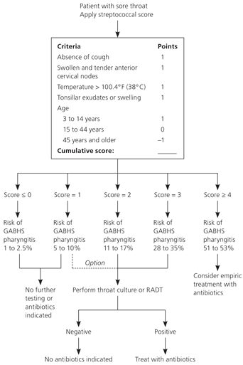
The modified Centor score in full. Four criteria at one point each, the age adjustment, and what each score band means. This slide’s text is a single caption line — the entire rule lives inside this picture. Slide 65
Structure | What to inspect, and what it means
Lips | Color, texture, cracks, sores. Angular cheilitis at the corners; angioedema; herpes simplex
Mucosa, tonsils, pharynx | Erythema, exudates, ulcerations, lesions. The posterior pharynx may need a tongue blade
Uvula and soft palate | Failure to rise with deviation of the uvula to the OPPOSITE side → cranial nerve X paralysis
Dentition | Caries, erosions. Look UNDER dentures for ulcers and lesions
Tongue | Texture, color, lesions. Smooth, beefy red → vitamin B12 deficiency. Cancers: lateral border or undersurface, indurated red or white, males over 50. Geographic tongue is benign. Asymmetric protrusion → cranial nerve XII lesion
Palpation | Floor of mouth; then the tongue — hold it with gauze in one hand and palpate with the other, then SWITCH HANDS for the opposite side

Switching hands is not fussiness, it is the only way to reach both lateral borders properly — and the lateral border and undersurface are exactly where the cancers are.
Pharyngitis: streptococcal gives erythematous tonsils, often with exudate. Candidal pharyngitis is its own picture. Necrotising ulcerative gingivitis — Vincent's angina, trench mouth — he described from the door [23:43]: “those people open their mouth back there and you can smell them over here, that’s how bad it is … the bacteria keep growing and it’s actually destroying tissue as it goes.” From poor dental hygiene, and drug use. Aphthous ulcers and torus palatinus — a benign midline bony growth on the hard palate — round out the findings.
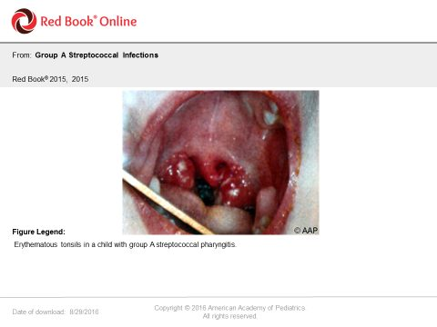
Erythematous tonsils in group A streptococcal pharyngitis. Redness and exudate score on Centor, but the picture alone does not settle it — that is what the rule is for. Slide 72
Also tested
- Removing dentures. Dentures are removed during the oral examination to look underneath for ulcers and lesions, since a denture hides the mucosa most at risk from chronic irritation.
- Centor rule. It is a clinical prediction rule that uses clinical features to decide how likely a sore throat is to be bacterial, converting findings into a probability and a course of action.
- Geographic tongue. It is a benign map-like pattern of patches, so recognizing it mainly avoids mistaking it for something that needs investigation.
- Centor criteria. The four are fever, tonsillar exudates, swollen anterior cervical adenopathy, and ABSENCE of cough; three are things present and one is a thing absent.

4.9 · The neck, the thyroid and the head
The node chains, in the order to palpate them: preauricular, postauricular, occipital, tonsillar, submandibular, submental, superficial (anterior) cervical, posterior cervical, deep cervical, supraclavicular. Use the pads of the index and middle fingers. Following a fixed route is what stops one being missed — and on the practical, each one has to be named as it is palpated.
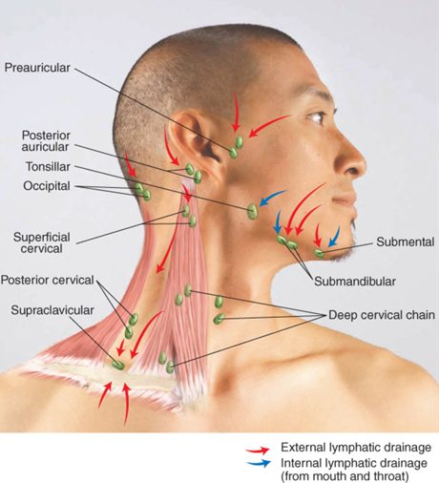
The neck node chains, with external (red) and internal (blue) drainage. Learn the route, because on the practical each chain has to be named as it is palpated . Slide 79
Node finding | What it means
Round or ovoid, smooth, mobile, non-tender | Normal
Tender | Inflammation
Hard or fixed | Malignancy
Enlarged supraclavicular node on the LEFT | Metastasis from an abdominal or thoracic malignancy
Generalized | Human immunodeficiency virus, Epstein-Barr virus, lymphoma, leukemia, sarcoidosis

The left supraclavicular node is the one worth knowing cold: it drains territory a long way from the neck, so finding one there redirects the entire search.
★ PROFESSOR EMPHASIS
★ Emergency — airway
Submandibular swelling and erythema — Ludwig's angina, a cellulitis of the floor of the mouth. Life threatening, and the reason is the AIRWAY.
He walked it through [28:16]: “that’s an emergency — basically an infection of the mouth, usually the lower, from teeth or something that went down. You’ve got the floor of the mouth, infection is right here, now it’s spreading this way and it spreads fast … it cannot stay in the body, it has to come out … life-threatening, airway. I saw a couple of those in the emergency room — you can see it spreading, you can see it moving, you have to work with it quickly.”

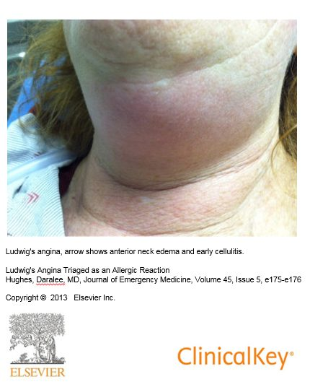
Ludwig’s angina — anterior neck edema and early cellulitis. It spreads fast and downward, and the airway is the reason it is an emergency. Slide 83
The trachea is checked for deviation — masses, atelectasis, or a large pneumothorax.
The thyroid, found from the cricoid cartilage as the landmark [26:43], and for diffuse enlargement, texture and tenderness give a first clue to which of three causes it is (blood tests then confirm it):
Finding | Suggests
Diffuse and SOFT | Graves disease
Diffuse and FIRM | Hashimoto thyroiditis
Diffuse and TENDER | Thyroiditis
Endemic goiter | Iodine deficiency
Single nodule | Cyst or tumor
Multinodular enlargement | Metabolic process; risk of malignancy with a family history

The head. History is OPPQRST again, and the headache patterns matter: migraine and tension are EPISODIC; migraine and cluster are UNILATERAL — migraine is in both lists, so the two features have to be read together. Sudden and severe → subarachnoid hemorrhage. New, progressive and persistent → mass. Also consider meningitis.
On examination: facial swelling or characteristic facies; lumps, rashes, hair loss, lesions, scars; lice; fine hair → hyperthyroidism, coarse hair → hypothyroidism; seborrheic dermatitis, psoriasis, atypical naevi, actinic keratosis; symmetry, involuntary movements, edema; tenderness and integrity; and size — enlarged in hydrocephalus and Paget disease, small in microcephaly.
NOTE
One gap, named rather than hidden. The deck declares Bates tables 7-1, 7-2, 7-4 and 7-19 through 7-26 testable, along with the material in the reading assignments. Those are a textbook, and nothing in this guide is invented from them — everything here comes from the slides or the recording. Where the deck reproduces a Bates table on its own slide, as it does for the vertigo comparison and the hearing loss summary, that content is above in full. For the rest, the tables are worth opening directly: 7-19 covers lumps on or near the ear, 7-22 the lips, 7-23 the mouth and pharynx, 7-25 the tongue, and 7-26 the thyroid.

Source: PD II ENT 2026.pptx (created by Megan B. Finck, MMS, PA-C; updated and presented by Rob Gray, DMSc, MMS, PA-C), Slides 1–95, and the lecture of 3 September 2026. Figures are reproduced from the lecture slides and each is cited to its slide.
Also tested
- Thyroid texture and tenderness. Texture and tenderness give a first clue to the cause, and blood tests then confirm: soft suggests Graves, firm suggests Hashimoto, and tender suggests thyroiditis.
- Firm thyroid. Firmness is the first clue that separates Hashimoto thyroiditis from Graves, where the gland is soft; blood tests then confirm the cause.

